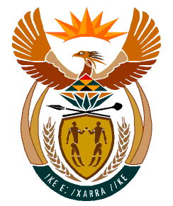

MINISTRY:
HUMAN SETTLEMENTS, WATER AND SANITATION
REPUBLIC OF SOUTH AFRICA

NATIONAL ASSEMBLY

QUESTION FOR WRITTEN REPLY

QUESTION NO.: 943

DATE OF PUBLICATION: 13 SEPTEMBER 2019

Mr J W W Julius (DA) to ask the Minister of Human Settlements, Water and Sanitation:
(1) Whether the Bekkersdal sewer rehabilitation project in Randwest City has been completed; if not, why not; if so, what are the relevant details;
(2) what (a) total monetary value was spent to date on the project and (b) are the reasons for non-completion? NW2097E

REPLY:

(1) According to the information provided by the Gauteng Department of Human Settlements, the Bekkersdal sewer rehabilitation project in Rand West City has not yet been completed. The work done to date accounts for a completion rate of 57%, and construction is still underway.

(2) (a) The amount spent to date on the Bekkersdal sewer rehabilitation project is R218 997 795.82

(b) The reasons for the non-completion of the project are as follows:
- The project did not commence on schedule due to community protests;
- There were labour issues between the contractor and workers which needed to be resolved prior commencement of the project;
- The project was further delayed by stoppages from the Department of Labour when it was mediating a dispute over salaries between the contractor and its workers.
- The Gauteng Department of Human Settlements was also not satisfied with the performance of the contractor and their concerns had to be resolved.

