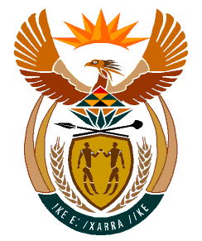

MINISTRY:
HUMAN SETTLEMENTS, WATER AND SANITATION
REPUBLIC OF SOUTH AFRICA

NATIONAL ASSEMBLY

QUESTION FOR WRITTEN REPLY

QUESTION NO.: 942

DATE OF PUBLICATION: 13 SEPTEMBER 2019

Mr J W W Julius (DA) to ask the Minister of Human Settlements, Water and Sanitation:
Whether there are any plans to complete the Droogheuwel water tower project in Randwest City Local Municipality after the budget for this project was wrongfully invested in the VBS Mutual Bank by the West Rand District Municipality; if not, why not; if so, what are the details of the plans? NW2096E

REPLY:

The Gauteng Department of Human Settlements has advised that plans are well underway to complete the Droogheuwel Water Tower Project. This is a multi-year project with a value of R169 000 000.00 and is currently 91% complete. It is anticipated that by end October 2019, the Gauteng Department of Human Settlements will transfer the balance of R 32 008 863.21 to the Rand West City Local Municipality which will effectively enable the total completion of the project.

I have been informed that the Rand West City Local Municipality has not invested funds in the VBS Mutual Bank. However, should the Honourable Member possesses information contrary to this, I would encourage him to send it to the law enforcement agencies for investigation.

