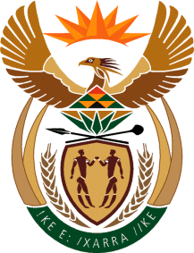

MINISTRY OF TOURISM
REPUBLIC OF SOUTH AFRICA

Private Bag X424, Pretoria, 0001, South Africa. Tel. (+27 12) 444 6780, Fax (+27 12) 444 7027
Private Bag X9154, Cape Town, 8000, South Africa. Tel. (+27 21) 469 5800, Fax: (+27 21) 465 3216

Ref: TM 2/1/1/10

MINISTER OF TOURISM

QUESTION FOR WRITTEN REPLY:
Question Number: 941
Date of Publication: 31 March 2017
NA IQP Number: 12
Date of reply: 26 April 2017

Mr C D Matasepe (DA) to ask the Minister of Tourism:

(1) Whether there is any position of (a) chief executive officer, (b) chief financial officer and/or (c) chief operating officer that is currently vacant in each entity reporting to him; if so, (i) how long has each specified position been vacant and (ii) what is the reason for each vacancy;

(2) have the vacancies been advertised; if so, (a) were interviews done and (b) on what date will the vacancies be filled;

(3) (a) what is the total number of persons who are currently employed in the specified positions in an acting capacity, (b) for what period has each person been acting in each position and (c) has any of the specified persons applied for the positions? NW1010E

Reply:
(1) SA Tourism has currently no vacancies for the (a) Chief Executive Officer, (b) Chief Financial Officer and (c) Chief Operating Officer positions.
(i) Not applicable
(ii) Not applicable

(2) There were no vacancies advertised by SA Tourism for the positions of Chief Executive Officer, Chief Financial Officer and Chief Operating Officer.
(a) Not applicable
(b) Not applicable

(3) (a) None
(b) Not applicable
(c) Not applicable

