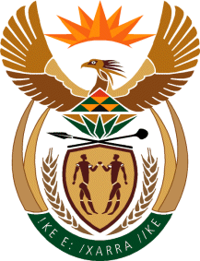

MINISTER IN THE PRESIDENCY: REPUBLIC OF SOUTH AFRICA
Private Bag X1000, Pretoria, 0001, Union Buildings, Government Avenue, PRETORIA
Tel: (012) 300 5200, Website: www.thepresidency.gov.za

NATIONAL ASSEMBLY
WRITTEN QUESTION FOR WRITTEN REPLY

QUESTION NUMBER: 940
DATE OF PUBLICATIONS: 19 March 2021

940. Dr M M Gondwe (DA) to ask the Minister in The Presidency:

(1) Whether, in view of the performance agreements that the President, Mr M C Ramaphosa, signed and concluded with the various Ministers, a framework has been developed to manage the performance of the Ministers; if not, why not; if so, was the framework approved by Cabinet;

(2) how often will the President review and assess the performance of the various Ministers;

(3) whether her Office will upload the performance reviews and assessments on its website, in an effort to promote accountability and transparency on the part of the Executive; if not, what is the position in this regard; if so, what are the relevant details;

(4) (a) how will the Deputy Ministers be reviewed and assessed and (b) will the President conclude performance agreements with the Deputy Ministers as well? NW1107E

REPLY:
- Yes, a framework was developed.
- The President will perform reviews annually considering performance score cards developed by DPME. DPME will also submit Mid-Year reports concerning progress in the implementation of the Annual Performance Plans (APP’s) of Departments. This will serve as early warning systems to identify areas that are lagging behind against the targets set in the APP.

(3) The Mid-Year performance reviews on the APP’s are published on the website after approval by Cabinet.
(4)(a) The performance agreements signed by the Ministers have included the delegated functions to Deputy Ministers.

Thank You.

