NATIONAL ASSEMBLY
36/1/4/1(201900222)

FOR WRITTEN REPLY
QUESTION 939
DATE OF PUBLICATION IN INTERNAL QUESTION PAPER: 13 SEPTEMBER 2019 (INTERNAL ciucsTlON PAPER NO 16-2019)

939. Mr A N Sarupen (DA) to ask the Minister of Police:

- Whether there are any police reservists stationed at the Actonville Police Station; if so, what (a) number of police reservists are stationed at the police station and (b) is the (i) rank, (ii) number of years of service and (iii) monthly hours of work of each reservist;

- whether any police officer stationed at the specified police station has been (a) inVestigated and/or (b) dismissed or prosecuted for any corrupt activities (i) in each of the past three financial years and/or (ii) since 1 April 2019; if so, what are the relevant details in each case;

- whether the police officers stationed at the specified police station are rotated regularly as a deterrent for them to get too relaxed in a specific posting, if not, what is the position in this regard; if so, what are the relevant details?
MW2093E
REPLY:

(1)(a) Yes, there are nine police reservists are stationed at the Actonville Police Station.

(b)(i)(ii)(iii)

(t)  Rank | (ii)  Number of years of service | (iii)  Monthly hours of work
R/Sergeant | 18 Years | 16 Hours
R/Constable | 11 Years | 16 Hours
R/Constable | 11 Years | 16 Hours
R/Constable | 11 Years | 16 Hours
R/Constable | 11 Years | 16 Hours
R/Constable | 12 Years | 16 Hours
R/Constable | 3 Years | 16 Hours
R/Constable | 3 Years | 16 Hours
R/Constable | 3Years | 16 Hours

(2)(a)(b)(i)(ii)

South African Police Service (SAPS) members | (')  In each of the past three financial years |  |  | Since 1  A f'iI 2019
 | 2016/2017 | 2017/2018 | 2018/2019
(a) Investigated for any  corrupt activities | 0 | *1 | 0 | 0
(b) Dlsmissed for any  corrupt activities | 0
(b) Prosecuted for any  corrupt activlties | 0 | 0 | 0
‘The details of the case that is being investigated, is as follows:

Case number | Charge | Outcome
Actonville, CAS 10/08/2017 | Corruption | Under investigation
(3) Yes, the last rotation was done on 1 November 2018, for the Community Service Centre Relief Officers.

Reply to question 939 recommended

CO
LE (SOEG)
GENERAL UTH AFRICAN POLICE SERVICE

Reply to question 939 appro\/ed/ v

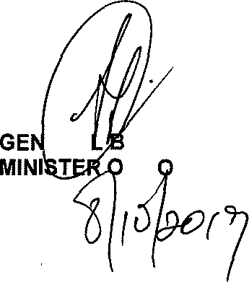

ERA H CELE (MP)
F P LICE
Date: @

