FOR WRITTEN REPLY
QUESTION 938

NATIONAL ASSEMBLY
36/1/4/1(201900220)

DATE OF PUBLICATION IN INTERNAL QUESTION PAPER: 13 SEPTEMBER 2019 “ (INTERNAL QUESTION PAPER NO 16-2019)
938. Mr A N Sarupen (DA) to ask the Minister of Police:

- Whether there are any police reservists stationed at the Benoni Police Station; if so, what (a) number of police reservists are stationed at the police station and
(b) is the (i) rank, (ii) number of years of service and (iii) monthly hours of work of each reservist;
- whether any police officer stationed at the specified police station has been (a) investigated and/or (b) dismissed or prosecuted for any corrupt activities (i) in each of the past three financial years and/or (ii) since 1 April 2019; if so, what are the relevant details in each case;

- whether the police officers stationed at the specified police station are rotated regularly as a deterrent for them to get too relaxed in a specific posting; if not,
what is the position in this regard; if so, what are the releVant details? ” NW2092E
REPLY:

(1)(a) Yes, there are eight active police reservists stationed at the Benoni Police Station.
(1)(b)(i)(ii)(iii)
(i) Rank | Number of  years of service | Mo hours of  work
R/Gonstable | 10 years | 16 hours
R/Constable | 10 years | 16 hours
R/Constable | 10 years | 16 hours
R/Sergeant | 23 years | 16 hours
R/Sergeant | 20 years | 16 hours
R/Constable | 12 years | 16 hours
R/Constable | 10 years | 16 hours
R/Constable | 10 years | 16 hours

”

(2)(a)(b)(i)(ii)

South African Police Service (SAPS) members | (i)  In each of tha past three financial years |  |  | (II)  Since 1 April  2019
 | 20J 6/2017 | 2017/2018 | 2018/20'I9
(a) investigated for any corrupt activities | 0 | 0 | 0 | 0
(b) dismissed for any corrupt activities | 0 | 0 | 0
(b) prosecuted for any corrupt actlvllles | 0 | 0 | 0 | 0
(3) Yes, the last rotation was done on 2 January 2016, for the Community Service Centre Relief Commander Officers.

Reply to question 938 recommended

GENERAL AFRICAN POLICE SERVICE
KJ
OM
(SOEG)
ER:

Reply to question 938 approved/

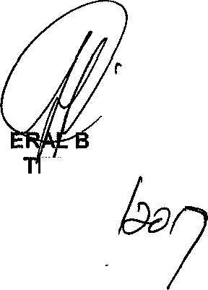

GEN H CELE (MP) MINIS ER POLICE
Date: &

