36/1/4/1(201900221)
NATIONAL ASSENIBLY

FOR WRITTEN REPLY QUESTION 937
OATE OF PUBLICATION IN INTERNAL QUESTION PAPER: 13 SEPTEMBER 2019 (INTERNAL QUESTION PAPER NO 16-2019)

937. Ms H Ismail (DA) to ask the Minister of Police:

- What (a) number of cases have been opened at the Benoni Police Station since 1 January 2019, (b) number of the specified cases have been solved, (c) are the details of the type of cases opened and (d)(i) number of the specified cases have been closed and (ii) was the reason in each case;

- what number of (a) vehicles does the specified police station currently have, (b) sectors does the police station have and (c) trained police officers are stationed at the police station?

REPLY:

(1)(a)

(1)(b)
(1)(c)

(d)(i)(ii)
NW2091E

A total of 4 176 cases have been opened at the Benoni Police Station, since 1 January 2019.
A total of 1 080 cases have been solved thus far.
The details of each type of case opened, for the period requested, form part of the crime statistics, which have not been released by the Minister of Police.
The details of the number of specified cases, which have been closed and the reason in each case, are reflected in the table below:

Charge |  | Nolle  (Dismissal of charges by the prosecution) | Insufficient  Evidence | False | Undetected
Murder | 0 | 7 | 0 | 0 | 2 | 9
Attempted murder | 0 | 7 | 0 | 1 | 0 | 8
Assault GBH | 2 | 23 | 0 | 2 | 0 | 27
Assault common |  | 80 | 0 | 15 ” | 1 | 102
Burglary business | 0 | 3 | 0 | 0 | 166 | 169
Burglary residential | 0 | 0 | 0 | 0 | 247 | 247
Shoplifting | 0 | 0 | 0 | 0 | 0 | 0

 | Withdrawn | Nolle Prosequi (Dismissal of charges by the prosecution) | Insufficient Evidence | False | Undetected | Total
Theft of motor vehicle and motor  cycle |  | 14 | 0 | 4 | 31 | 49
Theft at(Iirom motor vehicle | 0 | 17 | 0 | 3 | 76 | 96
Theft | 4 | 49 | 0 | 18 | 24 | 95
Maliciaus damage to property |  | 14 | 1 | 2 | 12 | 35
Ffaud | 0 | 47 | 0 | 14 | 10 | 71
Drug-related crime | 0 | 0 | 0 | 0 | 0
Driving under the influence of  alcohol or drugs | 0 |  | 0 | 0 | 0
Car jacking |  | 11 | 0 | 0 | 26 | 37
House robbery | 0 | 0 | 0 | 0 | 43 | 43
Business robbery | 0 |  | 0 | 0 | 31 | 40
Common robbery |  | 3 | 0 | 0 | 3 | 6
TOTAL | 18 | 285 | 1 | 59 | 672 | 1035

(2)(a) A total of 76 vehicles, are currently at the Benoni Police Station. (2)(b) The Benoni Police Station has seven sectors.
(2)(c) The Benoni Police Station currently has a total of 276 South African Police Service (SAPS) Act members.

Reply to question 937 recommended/

NA OM
KRS (SOEG)
Date: 019 11

GENERAL AFRICAN POLICE SERVICE

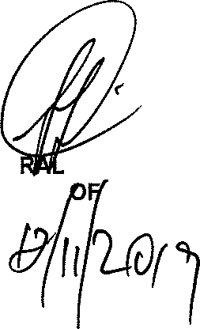
Reply to question 937 approve oved

GENE BH CELE (MP) MINISTER POLICE

Date:

