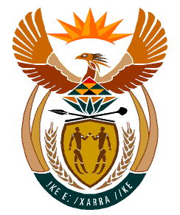

MINISTRY:
HUMAN SETTLEMENTS, WATER AND SANITATION
REPUBLIC OF SOUTH AFRICA

NATIONAL ASSEMBLY

QUESTION FOR WRITTEN REPLY

QUESTION NO.: 930

DATE OF PUBLICATION: 13 SEPTEMBER 2019

Ms E L Powell (DA) to ask the Minister of Human Settlements, Water and Sanitation:
By what date will all residents residing in the Alfred Nzo District Municipality have access to piped, potable water within a 100 metres from their homes? NW2083E

REPLY:

Currently, 45.9% of the residents of Alfred Nzo District Municipality have access to piped potable water supply as compared to 20.9% in 1994. According to the 2016/17 Water Services Master Plan for the Alfred Nzo District Municipality, an amount of R14, 6 billion is required to achieve universal access to water services in the entire District.

Grant funding received by the municipality averages R400 million per year against a requirement of R6, 1 billion over the Medium Term Expenditure Framework (MTEF). Should the current funding situation not change, it may take more than 10 years for all residents of the Alfred Nzo District Municipality to have access to piped potable water supply within 100 metres from their home.

