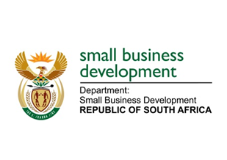
NATIONAL ASSEMBLY
QUESTION FOR WRITTEN REPLY
DUE TO PARLIAMENT: FRIDAY, 24 FEBRUARY 2023

“93. Mr G R Krumbock (DA) to ask the Minister of Small Business Development:
What are the details of the (a) make, (b) model, (c) year of manufacture, (d) cost and (e) purchase date of all the official vehicles purchased for (i) her, (ii) the former Minister, (iii) the Deputy Minister and the (iv) former Deputy Minister of her department since 1 June 2019?” NW97E

REPLY: I have been advised by the department as follows:

The Department of Small Business Development (DSBD) procured one vehicle since 01 June 2019 for the Minister of Small Business Development, which was transferred to the Department of Communication and Digital Technologies (DCDT) as per agreement between the incoming and outgoing Ministers to DCDT. The details are as follows:

(a) Make: Audi
(b) Model: Q5 40 TDI
(c) Year of manufacture: 2021
(d) Price: R726 469.25
(e) Purchase date: December 2021

No vehicle was purchased for the Deputy Minister of Small Business Development since 01 June 2019.

STELLA NDABENI-ABRAHAMS
MINISTER: SMALL BUSINESS DEVELOPMENT

