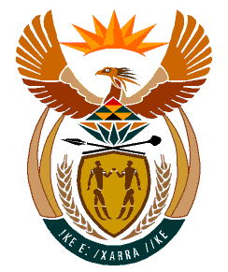

MINISTRY:
HUMAN SETTLEMENTS, WATER AND SANITATION
REPUBLIC OF SOUTH AFRICA

NATIONAL ASSEMBLY

QUESTION FOR WRITTEN REPLY

QUESTION NO.: 929

DATE OF PUBLICATION: 13 SEPTEMBER 2019

Ms E L Powell (DA) to ask the Minister of Human Settlements, Water and Sanitation:
What steps does her departments intend to take to (a) immediately remedy the total lack of clean running water which is experienced by more than 108 villages in Limpopo (details furnished) and (b) ensure that clean, piped water is immediately made accessible to residents of all 100 villages for which the Lepelle Northern Water Board is responsible for water provision? NW2082E

REPLY:

The Department of Water and Sanitation working together with various municipalities that are Water Service Authorities (WSA) in the Limpopo Province have and continue to implement a number of projects to remedy the lack of clean running water in the Limpopo Province. The Honourable Member is referred to Annexure A, attached, which indicates the eight Regional Bulk Infrastructure projects which have either been completed or are being implemented.

