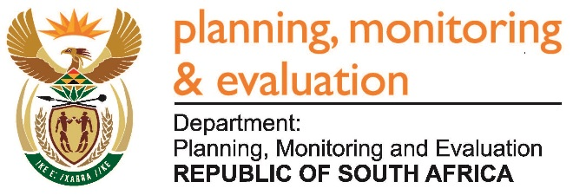 |  | 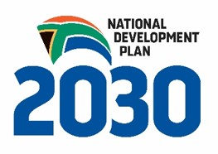
Private Bag X944, PRETORIA, 0001. Union Buildings East Wing, Government Avenue, PRETORIA
Tel: 012 312 0307. www.dpme.gov.za
929. Mr D W Macpherson (DA) to ask the Minister in The Presidency:

(1) Whether there is any position of (a) chief executive officer, (b) chief financial officer and/or (c) chief operating officer that is currently vacant in each entity reporting to him; if so, (i) how long has each specified position been vacant and (ii) what is the reason for each vacancy;

(2) have the vacancies been advertised; if so, (a) were interviews done and (b) on what date will the vacancies be filled;

(3) (a) what is the total number of persons who are currently employed in the specified positions in an acting capacity, (b) for what period has each person been acting in each position and (c) has any of the specified persons applied for the positions? NW998E

REPLY

There are no vacancies in regard to the mentioned positions.

Approved / Not Approved

Mr J T Radebe, MP

Minister in The Presidency

Date

