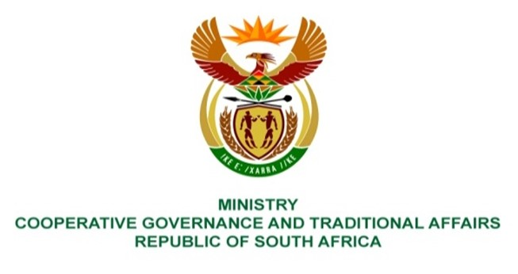

NATIONAL ASSEMBLY
WRITTEN

QUESTION NUMBER 928
DATE OF PUBLICATION: 18 MARCH 2022

QUESTION:

928. Mr I M Groenewald (FF Plus) to ask the Minister of Cooperative Governance and Traditional Affairs:
(1) What (a) is the total number of municipal entities in the Republic and (b) number of the specified municipal entities are development agencies reporting to her;
(2) (a) what total number of (i) municipal development agencies and (ii) other South African Municipal Government Entities were audited and (b) which of the specified agencies and/or entities received unqualified audit reports for (i) 2018, (ii) 2019 and (iii) 2020;
(3) which of the South African Municipal Government Entities fulfilled their annual objectives and mandates for every year since 2018? NW1163E

REPLY:

- (a) The number of municipal entities is 64.
(b) Municipal entities do not report to the Minister; however, the entities account to their respective parent Municipalities.
2. (a) and (b). The details of municipal entities are included in Annexure A, which contain list, names, audited and audit opinions of the municipal entities.
3. All entities fulfilled their reporting objectives except those that are dormant and Maluti a Phufong Development agency as per Annexure A referred above.

