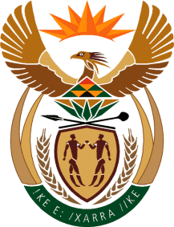

MINISTRY OF TOURISM
REPUBLIC OF SOUTH AFRICA

Private Bag X424, Pretoria, 0001, South Africa. Tel. (+27 12) 444 6780, Fax (+27 12) 444 7027
Private Bag X9154, Cape Town, 8000, South Africa. Tel. (+27 21) 469 5800, Fax: (+27 21) 465 3216

NATIONAL ASSEMBLY:

QUESTION FOR WRITTEN REPLY:
Question Number: 925
Date of Publication: 19 March 2021
NA IQP Number: 9
Date of reply: 15 April 2021

Mr M S F de Freitas (DA) to ask the Minister of Tourism:
(a) At what stage is the process of the rebranding of SA Tourism currently, (b) what changes are perceived for the final brand for SA Tourism, (c) how has SA Tourism communicated the current brand positioning exercise, (d) what (i) government and (ii) private sectors have been brought in to be part of the process in each sector and (e) what budgetary amount has been allocated for each line item for this purpose?
NW1092E

REPLY:

- Government is currently undertaking a process to look at repositioning its public entities including South African Tourism (SA Tourism). Recommendations emanating from this process will be discussed and approved by Cabinet hence SA Tourism has not initiated rebranding of the entity.

(b)- (e) Not applicable

