FOR WRITTEN REPLY

QUESTION 922

NATIONAL ASSEMBLY
36/1/4/1(201900219)

DATE OF PUBLICATION IN INTER AL auEsTiON PAPER: 13 SEPTEMBER 2019 (INTERNAL QUESTION PAPER NO 16-2019)
922. Mr C Brink (DA) to ask the Minister of Police:

Whether the (a) Lyttleton, (b) Olievenhoutbosch, (c) Erasmia, (d) Wierdabrug and (e) Laudium Police Stations have cells to detain arrested persons overnight; if not, in each case, (i) which police station does not have the requisite cells and (ii) where are arrested persons detained overnight; if so, what number of arrested persons can be detained overnight in each case?
NW2075E
REPLY:

(a)(b)(c)(d)(e)(i)(ii)
(i) Police Station |  | Does the police station have cells to detain arrested pemons overnight
 |  | Has  cells | Where are the arrested persons detained overnight | Humber of arrested persons that can be detained overnight
(a) | Lyttelton | No | Sunnyside Pollce Station | Nine male cells and one femala cell. Each cell can accommodate eight detainees.
(b) | Olievenhoutbosch | No | Wierdabrug Pollce Station | Four male cells, which can accommodate 15 detainees and one female cell, which can accommodate flve detainees.
(c) | Erasmia | No | Atterideeville  Pollce Station | Six male cells, one juvenile cell,  one female cell, one lesbian, gay, bisexual, transgender, queef or questioning, and intersex (LGBTQI) cell, which can each accommodate 10  detainees.
(d) | Wierdabrug | Yes | Wierdabrug Police Station | Four male cells, which can each accommodate 15 detainees and one female cell, which can accommodate five detainees.
(e) | Laudium | No | Atteridgeville Police Station | Six male cells, one juvenile cell,  one female cell, one lesbian, gay, bisexual, transgender, queer or questioning, and intersex (LGBTQI) cell, which can each accommodate 10 detainees.

Reply to question 922 recommended/bed

GENERAL
ER:
H
KJ
(SO
AFRICAN POLICE SERVICE

Date: 20\9 - iu- IJ 1
Reply to question 922 appro\led/npfapp m
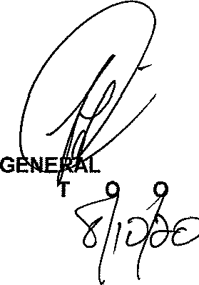

BH CELE (MP) MINIS' ER F P LICE
Date:

