FOR WRITTEN REPLY
QUESTION 918

NATIONAL ASSEMBLY
36/1/4/1(201900231)

DATE OF PUBLICATION IN INTERNAL QUESTION PAPER: 13 SEPTEMBER 2019 (INTERNAL QUESTION PAPER NO 16-2019)

918. Mrs C Phillips (DA) to ask the Minister of Police:

How long do the DNA tests from rape kits take before the results are made available to the investigating officer?
NW2071E
REPLY:

For a routine case, with one suspect reference sample and one Sexual Assault Evidence Collection Kit from the victim, it will take 35 calendar days to complete.

For a non-routine case, with multiple suspect reference samples, one Sexual Assault Evidence Collection Kit and additional exhibits (clothing/bedding) from the victim, it will take 113 calendar days to complete.

On average and with the required resources consistently available, the South African Police Service (SAPS) Forensic Science Laboratory (FSL) requires 74 calendar days, taking the above scenarios into consideration.

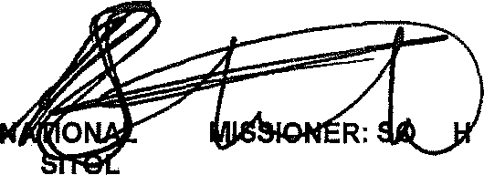
Reply to question 918 recommended/

COM
KJ E (SOEG)
Date: ]8\9 -!! ' 7
GENERAL UT AFRICAN POLICE SERVICE

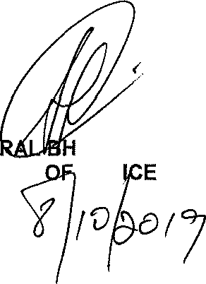
Reply to question 918 approved/

GENE CELE (MP)
MINISTER POL
Date: @

