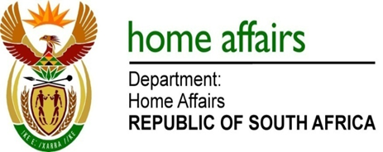

NATIONAL ASSEMBLY

QUESTION FOR WRITTEN REPLY

QUESTION NO. 918

DATE OF PUBLICATION: Monday, 11 April 2016

INTERNAL QUESTION PAPER 10 OF 2016

918. Ms H O Hlophe (EFF) to ask the Minister of Home Affairs:

(1) Has he earned any additional income from businesses, in particular businesses doing work for the Government, since his appointment as Minister; if so, (a) when, (b) how much did he earn, (c) from which businesses and (d) for what work;
(2) whether his (a) spouse, (b) children and (c) close family earned income from businesses, in particular businesses doing work for the Government, through his appointment as Minister; if so, in respect of each case, (i) when, (ii) how much did each earn, (iii) from which businesses and (iv) for what work? NW1044E
REPLY:

(1-2) No.

