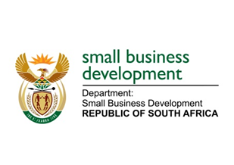
NATIONAL ASSEMBLY
QUESTION FOR WRITTEN REPLY
DUE TO PARLIAMENT ON FRIDAY, 5 JUNE 2020

916. Mr W W Wessels (FF Plus) to ask the Minister of Small Business Development:

- Whether her department awarded any tenders connected to the Covid-19 pandemic; if not, what is the position in this regard; if so, what (a) are the names of the businesses to whom these tenders were awarded, (b) are the amounts of each tender awarded and (c) was the service and/or product to be supplied by each business;

- whether there was any deviation from the standard supply chain management procedures in the awarding of the tenders; if so, (a) why and (b) what are the relevant details in each case;

- what was the reason for which each specified business was awarded the specified tender;

(4) whether she will make a statement on the matter?
NW1205E

REPLY:

- (a) – (c) To date, the Department did not issue any tenders related to COVID-19.

- (a) – (b) The Department did procure some goods and services through deviation as well as through RT 15/2016 contract, in preparation for the lockdown and work from home / remote working environment, the Department deviated from the normal procurement processes to procure the following:
- A total of 75 laptops and 75 laptop bags for officials that ordinarily used desktop computers but needed remote connection due to the lockdown. The reason for deviation was that the store that these were purchased from was the only retailor that was able to supply the required number and specifications at short notice, before 26 March 2020, following the President’s announcement of the lockdown, which was on 23 March 2020.
- Data cards and Wi-Fi routers, 75 each, through the RT 15/2016. The RT 15/2016 is a contract that was awarded to a specific mobile service provider to supply and deliver mobile communication services for government, hence no other quotations were sourced.
- A total of 1000 masks. The service provider was sourced from the list that was provided by National Treasury and was the only service provider who had the required stock to deliver before the lockdown that started on 26 March 2020, following the President’s announcement of 23 March 2020. This was to enable DSBD officials who may still be coming to the office to have Personal Protective Equipment (PPE).
- Not applicable, as no tenders were awarded.
- No

