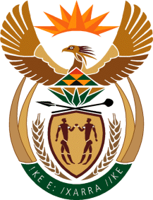
MINISTER IN THE PRESIDENCY: REPUBLIC OF SOUTH AFRICA
Private Bag X1000, Pretoria, 0001, Union Buildings, Government Avenue, PRETORIA
Tel: (012) 300 5200, Website: www.thepresidency.gov.za
NATIONAL ASSEMBLY
QUESTION FOR ORAL REPLY
QUESTION NUMBER: 913

913. Ms N V Mente (EFF) to ask the Minister in The Presidency:

(1) Has he earned any additional income from businesses, in particular businesses doing work for the Government, since his appointment as Minister; if so, (a) when, (b) how much did he earn, (c) from which businesses and (d) for what work;

(2) whether his (a) spouse, (b) children and (c) close family earned income from businesses, in particular businesses doing work for the Government, through his appointment as Minister; if so, in respect of each case, (i) when, (ii) how much did each earn, (iii) from which businesses and (iv) for what work? NW1039E

REPLY:

I wish to refer the Honourable Member to the Office of Registrar of Member’s Interest in Parliament where I have made submissions since becoming a Minister.

