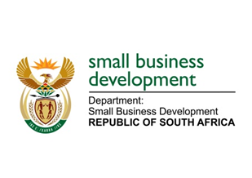
NATIONAL ASSEMBLY
QUESTION FOR WRITTEN REPLY
DUE TO PARLIAMENT ON FRIDAY, 5 JUNE 2020

911. Mr V Zungula (ATM) to ask the Minister of Small Business Development:

What steps is she taking to (a) assist small businesses with access to computers so that they can access Government support, (b) bring online (i) the unregistered businesses and (ii) those whose tax clearances are invalid and (c) ensure that the micro/informal economy is reserved only for South Africans? NW1200E

REPLY:
- A number of Seda offices have desktop computers at their reception areas where SMMEs can have access to the internet. It is envisaged that the footprint of these will be expanded such as to expand access to the rest of the Offices. Where Seda does not have physical offices, there are co-location points set up with municipalities and other provincial and district entities where Seda Business Advisors visit according to scheduled intervals on a weekly basis.

- (i)-(ii) The Department launched the first database of SMMEs in the country (www.smmesa.gov.za) which enables all SMMEs to register and receive a unique registration number. This is now linked to the application process for financial and non-financial support so that when an enterprise applies for support they do not have to fill information that is already on the database therefore as someone as someone enters the registration all the information is retrieved and the enterprise will only focus on providing information that is required for that particular application. The SMMESA already interfaces with SARS and UIF whilst work is underway to interface with CIPC (BizPortal) and CSD. All these measures will ensure that those businesses that are not registered are registered and their tax matters are compliant.

In addition, as part of Business Development Services, one of Seda’s priorities is to ensure that unregistered businesses are assisted with Companies and Intellectual Property Commission (CIPC), SARS and UIF registration processes. This is done through CIPC’s BizPortal.

- The DSBD, ensures that all micro / informal businesses who are assisted by DSBD are owned by people with the valid 13-digit barcoded South African identity document. The Department has been tasked to provide the Department of Home Affairs (DHA) with guidelines on sectors that must be reserved for South Africans and this process is almost complete. The Department is working with DHA and the Department of Trade and Industry and Competition to ensure that these sectors are designated. Consultations are underway with the affected and relevant sectors.

