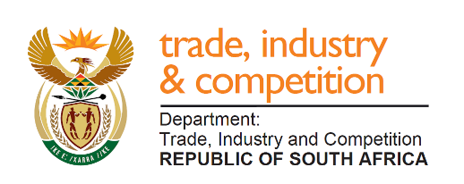

THE NATIONAL ASSEMBLY
QUESTION FOR WRITTEN REPLY
PARLIAMENTARY QUESTION 91

Mr M J Cuthbert (DA) to ask the Minister of Trade and Industry:
(1) What was the cost of his trip to the meeting of the 2020 World Economic Forum in Davos, Switzerland, in terms of (a) flights and accommodation, (b) daily allowance and (c) the (i) number of employees from his private office that attended and (ii) total cost for them to attend;
(2) whether he flew in economy class to Davos, Switzerland; if not, why not; if so,
(3) whether he intends flying economy class when attending to official business abroad; if not, why not; if so, what are the relevant details? NW100E

REPLY

The trip to the World Economic Forum in January 2020 combined three separate meetings in one round-trip. These were:
- The 2020 World Economic Forum meeting held in Switzerland to meet investors, analysts and foreign government representatives
- The World Trade Organisation “Mini-Ministerial” meeting on trade, held in Switzerland to consider the progress made on trade reform at global level
- A session of the African Union’s Bureau of the Council of Ministers held in Ethiopia, to shortlist candidates for the Secretary General position for the new Secretariat of the AfCFTA.
The travel schedule was a flight from Johannesburg – Zurich followed by a car journey to Davos and back to Zurich; with flights from Zurich-Vienna (transit) – Addis Ababa (meeting) – Johannesburg. Travel for international visits are in business class.
The cost for the Addis Ababa meeting will be compensated by the African Union, as I attended in my capacity as Vice Chairperson of the Council of Ministers. The cost of travel, excluding the portion for which a refund has been made to the African Union, is R111 383, covering both airfare and accommodation.
A Ministerial Advisor attended the WEF meeting, at a cost of R58 454 and flew economy class.
No accompanying person from the Ministry travelled to Ethiopia for the African Union segment.

-END-

