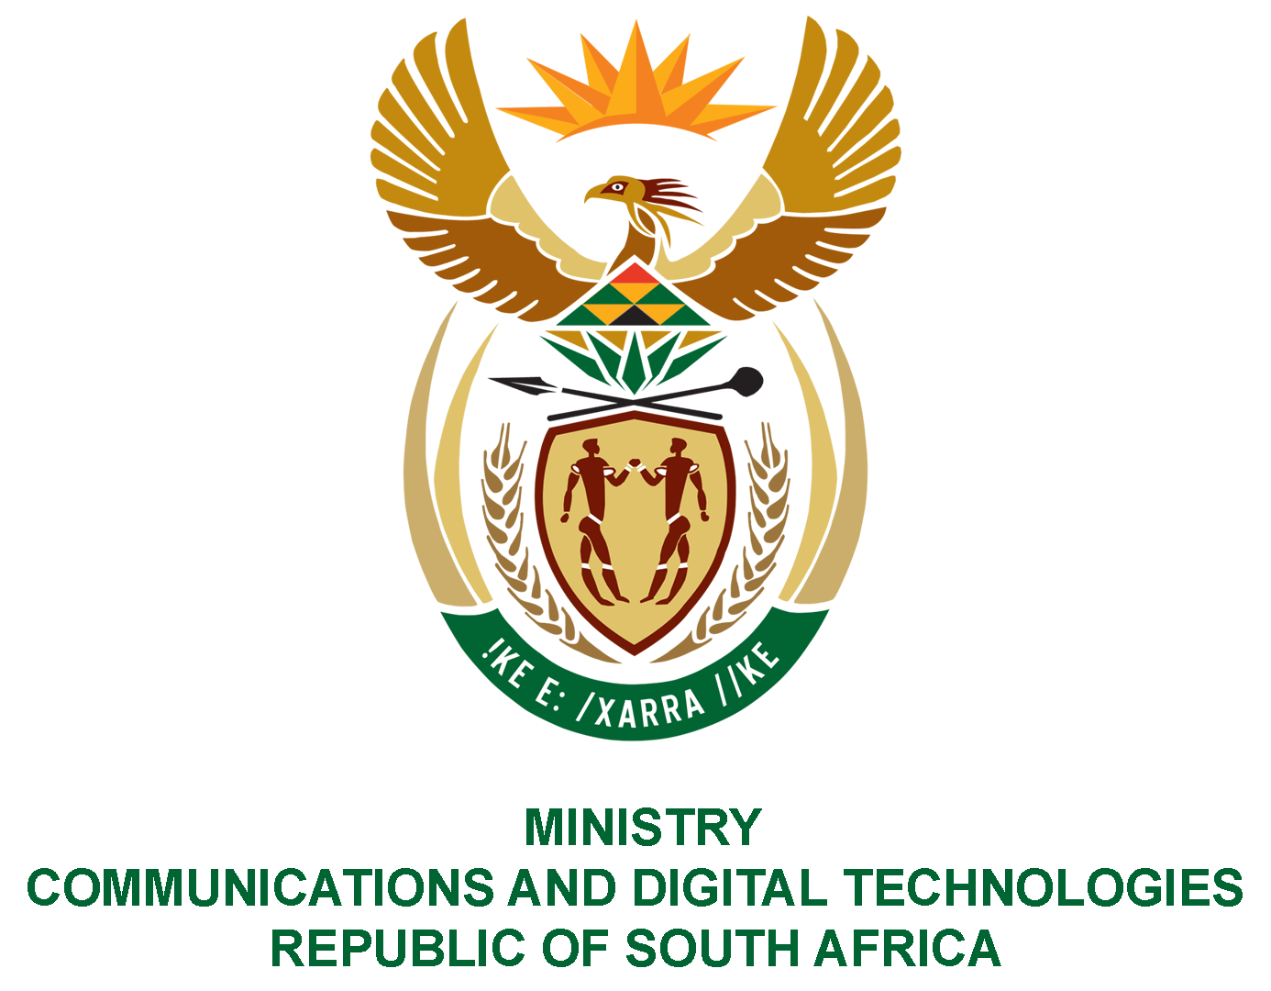

PARLIAMENT OF THE REPUBLIC OF SOUTH AFRICA

NATIONAL ASSEMBLY

WRITTEN REPLY

QUESTION: 909

DATE OF PUBLICATION: 11 MARCH 2022
QUESTION PAPER NO: 09

Ms Z Majozi (IFP) to ask the Minister of Communications and Digital Technologies:
Whether, in light of the assertion by the Executive Director of the African Union Mechanism for Police Cooperation, Mr Tarek Sharif, that cybercrime is one of the most rapidly developing offences among the fastest growing forms of transnational crime facing member states of the African Union, and in view of the Cybersecurity Workforce Study which found that women only make up 25% of the global cybersecurity workforce, her department has programmes in place to promote the training and recruitment of women in the cybersecurity sector; if not, why not; if so, what are the relevant, full details?
NW1091E

REPLY:

I have been advised as follows:-
No, the Department does not have programmes in place to promote cybersecurity training as the Department does not gave a training mandate.

However, the Department identified a gap in cybersecurity skills in the country and at present, partnered with the Bank SETA and the South African Banking Risk Information Centre (SABRIC) to develop a National Cybersecurity Skills Framework to guide the training of cybersecurity professionals by the relevant institutions.

