36/1/4/1(201900230)
NATIONAL ASSEMBLY

FOR WRITTEN REPLY QUESTION 908
DATE OF PUBLICATION IN INTERNAL QUESTION PAPER: 13 SEPTEMBER 2019 (INTERNAL QUESTION PAPER NO 16-2019)

908. Mr A G Whitfield (DA) to ask the Minister of Police:

With reference to his reply to question 383 on 3 September 2019, what number of detectives was employed by SA Police Service (a) at each police station, (b) in each cluster, (c) in the (i) 2014-15, (ii) 2015-16, (iii) 2016-17, (I\/) 2017-18, (v) 2018-19 and
(vi) 2019-20 financial years in Limpopo, Western Cape, Northern Cape, Eastern Cape, Mpumalanga, Free State, KwaZulu-Natal and North West provinces?
NW2060E
REPLY:

(a)(b)(c)(i)(ii)(iii)(iv)(v)(vi)

The number of detectives, employed by the South African Police Service (SAPS) at each police station, in each cluster, in the 2014/2015, 2015/2016, 2016/2017, 2017/2018, 2018/2019 and 2019/2020 financial years, in Limpopo, Western Cape, Northern Cape, Eastern Cape, Mpumalanga, Free State, KwaZulu-Natal and North West provinces, is attached as per annexures A and B.

Reply to question 908 recommended/

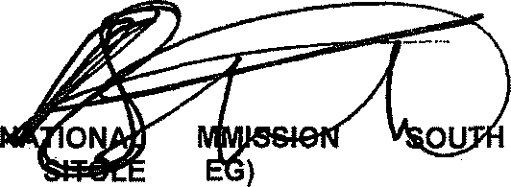GENERAL AFRICAN POLICE SERVICE
KJ
CO (SO
ER:

Date: ]g]§ -0§- 2 7
Reply to question 908 approved
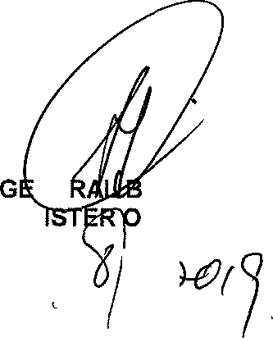
NE MIN
H CELE (MP) F OLICE
Date: '0

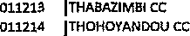
ozzzcnvc nR cazAcnY As czumTt mez Ice Derrcm's cooRoJucAn - oozsos j
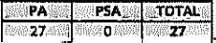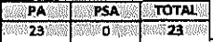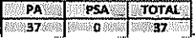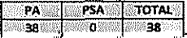
ozzzoz {cRoatzesDAc cc
OM304 LEPklAtALE W
ozzzos }smani cc
0TMo6 MAHWELGRENG CC
0M207 MAKNADO CC
o„2i, )*oro wAw*cc |  |  | 0 | V
0$T2Z2 SMfiEGO CC
OT:t2:t5 | TtJBAY5E W
OMM6 | TZANEEt'J CC
ozzzzv | aunsr«sronT cc | 0 | o | g
0:t12N | MANKWENG CC | 0 | 0 | 0

PA | PSA | TOTAL
D
i | o | i
s | o | 3
o | o | o
o | o | 0
o | o | o
0 | o | o

PA | PSA | TOTAL
 | 0
o | o | o
o | o | o
 | 0 | *
z | o | z
4 | 0 | A
4 | 0
 |  | A
0 | 0 | o

1 | 0
 | 0
o | o | o
a
0 | o | o
4 | o | 4

ee | 'SA | TOTAL
o | o | o
s | o | s
s | a | s
o | 0 | 0
i | 0 | t

 | 0
 | 0
 | 0
2 | 0
9 | 0 | A
2 | 9
s | o | s
& | 0 | A
0 | D | A
z | o | 3
 | 0 | ›

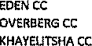
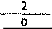

1616
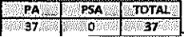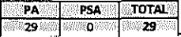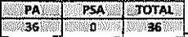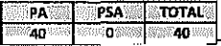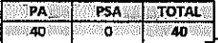
 |  | YA | PSA | TIAL
 |  | 1
oinsoi | WLEDOfiI CC |  | 0
 | CAPETOWN CC
 | CEREs CC
 | CLAREMONT CC
 | DA G AMASKOP CC
0t0s:IO
010812 |  |  |  | 2
010ST | MIINERTON CC
 | M ITCHEtLS PLATSI CC | 2
 | MU IZENBEgG K
 | tJYANGA CC
Oj0gz9 | OtJQTSHOORN CC
 | WINELAXoS CC | 2
 | VREDENeuflG CC |  | 0
 | V REDELIOA L CC |  | 0
 | WORCESTER CC |  | 0

PA | P$A | TOTAL
2 |  | 2
2 | 0
 | 0
2
2 | 0
 | 0
 | 0
2

0 | 0
 | 0
 | 0
 | 0
 | 0
0
 |  | 2

0
0
2
0
0
0
0

0 | 0
 | 0
 | 0
 | 0
0
 | 0
 | 0

 | 0 | 0
 | 0
 | 0
 |  | 2
 | 0
 | 0

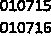
ozzzcnvz HR c#eacrrY az cwmR tzvEulcc omczivz coonDinamon - oozsoa j
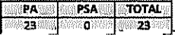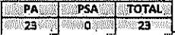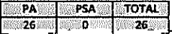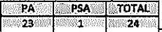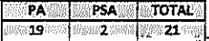
01O7O1 | CALVIf'IIA CC | 1 | 0 | i
0T070Z | CARNA9VON CC
070708 | PIPING KA SEMG K
010704 | GALEST4EWE CC
 | HAeTswAnR cc
0T0706 | OOPETOWrJ CC | 1 | n | 1
010708
01Q710 | JT GAETSME cC
01O7t1 | POFADDEB Cc
 | PORT f'IOLLOTFI cC
 | eonmsuRs cc
 | PRIESM CC

i |  | o | i
2 |  | 4 | z
z |  | o | z
 |  | 0
2

0
2

0 | 0 | 0
o | o | o
4 | 0 | 4
0 | 0 | 0
p | g | g
0 | 0 | 0
0
0 | 0
 | 0
 | 0
0 | 0
 | 0

PA | PHA | TOTAL
0 | n | It
n | 0 | 0
o | o | g
p | p | g
D | D | 0
0
0
 | 0

PA | PHA | TOTAL
o | 0 | g
0 | 0 | 0
0 | 0 | 0
Q | 0 | 0
0 | 0 | 0
0 | 0
o
o
o
2

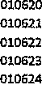
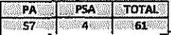
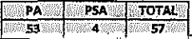
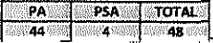
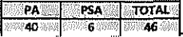
 |  | PA | PSA | TOTAL
010602 | AURAL f'IOTtTH CC
 | BUTT8RWORTF CC
0:t0604 | RFITvIVABA K
0E0606 |  |  |  | 2
circus | GRAAFG-REINET CC
Ot0609 | GRAIJAMsTQWf'I CC
 | nuvusoonr cc
 | KING WIL\IAMST CC |  | 0
 | MATATSLS CO |  | 0
 | MOANTsANE CC
 | MOTHERW5(L CC
 | MOUNT AYUFF CC
 | MOUNT FLETO4ER CC |  | 0
 |  | 2 | 0
 | MQALIDU M CC |  | 0
 | ITT ATHA CC
 | PEDDI E CC | 2 | 0
 | POgT AL£TtEo CC
 | POgT Sr JO)JNB CC |  | 0
 | auernsTown cc
0t06\s | U frENHAGE CC |  | 0
010626 | WprFrtESEA CC |  | 0
 | WILLOWMOP8 CC |  | 0

 | 0
 | 0
 | 0
 | 0 | 2
 | 0
 | 0
 | 0
 | 0

2
2
 | 0
2
2 | 0
 | 0
 | 0
 | 0

0
0
0
0
0
0
0
0

PA | PSA | TOTAt
 | 0
 | 0
 | 0
0
0
 | 0
0 | 0
 |  | 1
 |  | 4
 |  | 3
 | 0
 | 0

PA | PSA | TOTAL
0
 | 0
2
 | 0
0
0

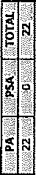

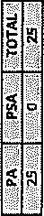

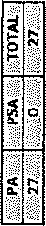

8*
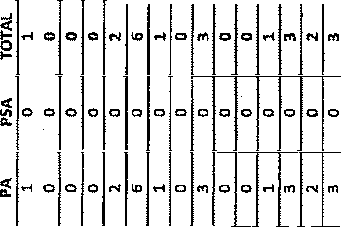
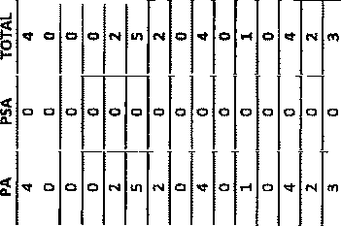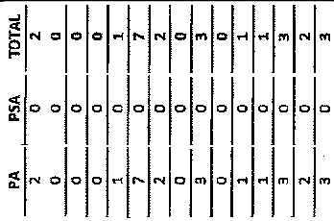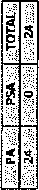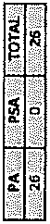.

,3
9
8

o i
. 3
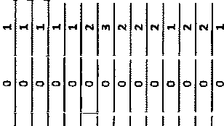
X*

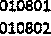
1816
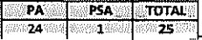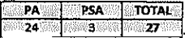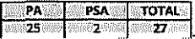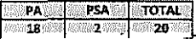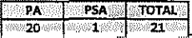
 | 8ETHL5HEM CC
 | BUL FONTOM CC
0 | MAFIGAtJFiG CC | 2 | 0
010B09 | eAn«aoAo cc |  | 0
 | PHuTBADmFiAaA cc |  | 0
 | MMDEfA CC |  | 0
mwu | SELOSESHA CC |  | 0
 | SMTThFIELO CC
 | 7 IABOf'IG CC
 | TgOMP6BU RG W

1 | A
 | 0
 | 0
1

PA | g5A | TOTAL
Q | o | p
 | 0
 | 0

o | o | o
 |  | o ‘
 | 0
 | 0
 | 0
0

2
0
0

0 | o | 0
 | 0 | 2
 | 0

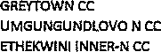

16 6
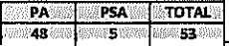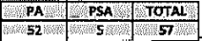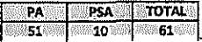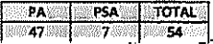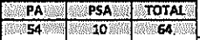
 |  | PA | f'gA | TOTAL
 | ETNEMILII IFINER•S Cc
 | HEMILII CENT\A L CC |  | 0
 | etvir4NeeNi cc |  | 0
0z0906 | RIf'IG CET\HWAYO E |  | 0
0E09os
 |  | 2
 | HARRY GWAL4 DC |  | 0
OH 13 | I L5M8E CC
 | UMItFIANYAKLiDE CC
 | uTnucrLa cc
 | MA RGATE CC
 | AMAJU BA CC
 | ETHEItWI f'II OUTEfI-N CC
 | UMGUSGU NDLOVO S CC
010920 | ETNEMINI If'IN•OLrf CC
 | PMSJSLAER CC
01n922 | uGu CC
010923 | zurvmno cc
 | EN+4CMTf'II OUTER-5 CC
01tT925 | VRYHEIO CC

0
2

PA | PHA | YOTAL
2
 | 0
 | 0
2 | 0

0
0
0
0
0
0

PA | PHA | TOTAL

PA | PSA | TOTAL
2
0
2
 | 0
 | 0
 | 0

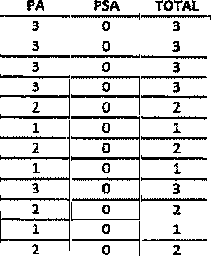
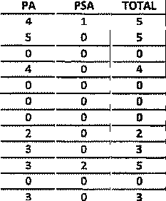
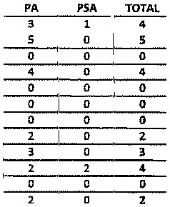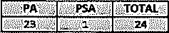
2
0

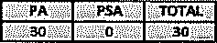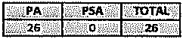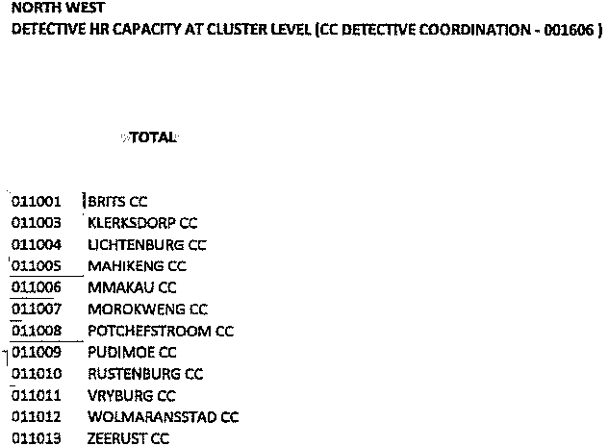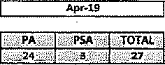
P

