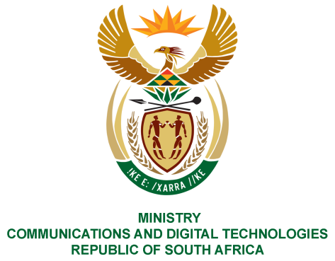
PARLIAMENT OF THE REPUBLIC OF SOUTH AFRICA
NATIONAL ASSEMBLY
WRITTEN REPLY

QUESTION NO: 907
DATE OF PUBLICATION: 17 March 2023
QUESTION PAPER NO: 10
Ms T Bodlani (DA) to ask the Minister of Communications and Digital Technologies:
(1) Whether he will appoint the existing staff in his office; if not, will he take his staff from his previous portfolio with him; if so,
(2) whether he will furnish Ms T Bodlani with a full breakdown of all his staff in his personal office with reference to, (a) the positions they occupy, (b) their salary bands and (c) their highest qualifications; if not, why not; if so, what are the relevant details? NW1013E

REPLY:
- No. This information is not available at the moment. It should be noted that the changes to the Cabinet announcement was made on 6 March 2023 and staff appointed per term of office of the incumbent executive authority or Deputy Minister will only terminate at the end of the first month after the month in which the term of that executive authority or Deputy Minister terminates for any reason. (Regulation 66 of the Public Service Regulations, 2016)

- This information will be available after 1 May 2023 when appointments in the office of the Minister have been finalized.

Thank You.

