NATIONAL ASSEMBLY
QUESTION FOR WRITTEN REPLY
PARLIAMENTARY QUESTION NO: 907
DATE OF QUESTION: 19 MARCH 2021
DATE OF SUBMISSION: 07 APRIL 2021
Ms L H Arries (EFF) to ask the Minister of Justice and Correctional Services:
What total number of (a) cases of domestic violence were prosecuted over the past five years and (b) the specified cases have resulted in convictions?
NW1074E

REPLY:

- It must be noted that there is no offence per se called “domestic violence”, it is rather a collective of offences related to the Domestic Violence Act or other relevant legislation (for example: Protection from Harassment Act) or even other related common law offences which displays evidence of domestic violence in the merits of the case (for example: attempted murder).

The National Prosecuting Authority (NPA) does not collate offence specific statistics, therefore we extracted the information as is available on the ECMS. The information reflected only relates to main charges and would not indicate those cases where a different main charge such as assault, attempted murder, malicious injury to property, etc have been added. Secondly, the extracted information only relates to offences linked to the particular Acts of which three (3) contraventions are available namely:
Source | Description
- Section 18(1)(a) read with section 10(1) or (2) of the Protection from Harassment Act 17 of 2011 | Contravening a prohibition, condition, obligation or order imposed by a court by means of a protection order.
- Section 6(a) read with section 2 and 4 of the Prevention of Family Violence Act 133 of 1993 | Contravening an interdict or other order granted by a judge or magistrate in a domestic violence incident.
- Section 7(1) read with section 17 of the Domestic Violence Act 116 of 1998 | Contravening the conditions of domestic violence protection order.

The following information, as extracted, is only with reference to contraventions on the aforementioned legislation. The previous disclaimers as explained in the second paragraph should also be kept in mind. A comparison of cases finalised between April 2019 and March 2020 compared with the verdicts finalised with a verdict between April 2020 and March 2021 is depicted in Figures 1 and 2 for District and Regional court respectively.
Figure 1: Verdicts Apr 19- Mar 20 compared to Apr 20 – Mar 21 in DC
Light blue reflects the 2020/21 FY for number of verdict cases finalised per month. The decrease in numbers as indicated is due to the impact of covid-19 and related restrictions. The dark blue information reflects the previous 2019/2020 FY.
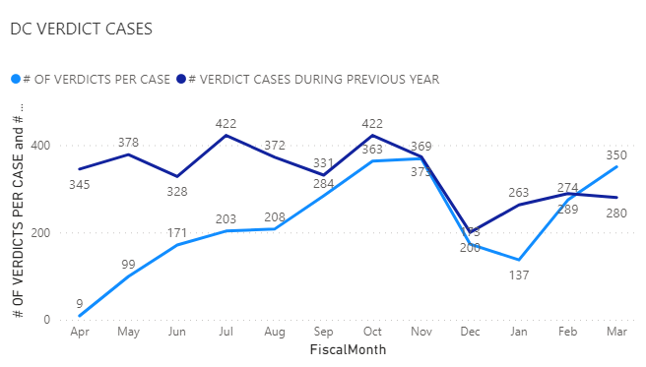

Figure 2: Verdicts Apr 19- Mar 20 compared to Apr 20 – Mar 21 in RC
Light blue reflects the 2020/21 FY for number of verdict cases finalised per month. The decrease in numbers as indicated is due to the impact of covid-19 and related restrictions. The dark blue information reflects the previous 2019/2020 FY. The lower numbers in the Regional Court is attributed to the fact that the predominant number of these contraventions of orders are dealt with in the District Courts.
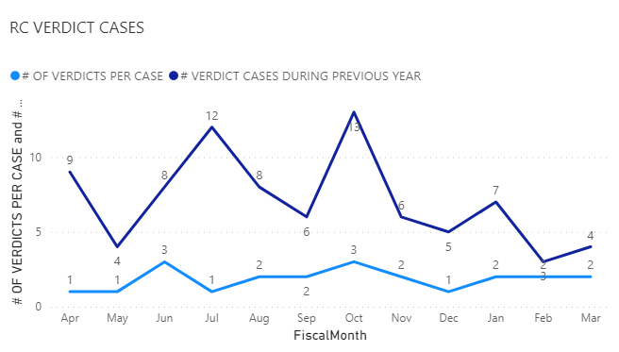
Similarly, a comparison of cases finalised between April 2018 and March 2019 compared with the verdicts finalised with a verdict between April 2019 and March 2020 is depicted in Figures 3 and 4 for District and Regional court respectively.

Figure 3: Verdicts Apr 18- Mar 19 compared to Apr 19 – Mar 20 in DC
Light blue reflects the 2019/20 FY for number of verdict cases finalised per month. The dark blue information reflects the previous 2018/2019 FY.
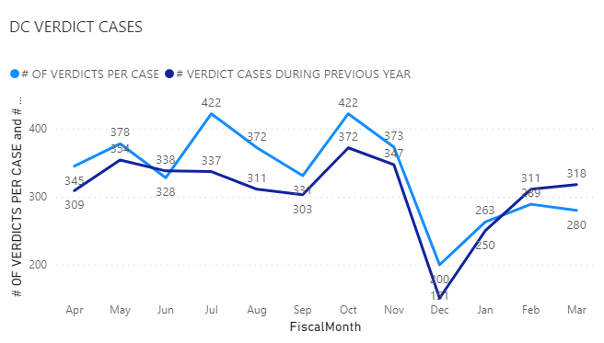

Figure 4: Verdicts Apr 18- Mar 19 compared to Apr 19 – Mar 20 in RC
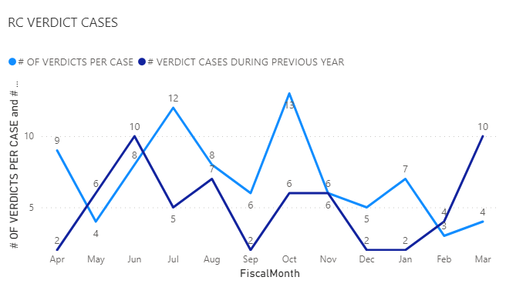

- The number of convictions resulting from the verdict cases are depicted in Figures 5 and 6 for the period April 2020 to March 2021; respectively for the District court and the Regional court. The conviction rates during this period for the District court was 77.9% and in the Regional court 77.3%.

The number of convictions resulting from the verdict cases are depicted in Figures 7 and 8 for the period April 2019 to March 2020; respectively for the District court and the Regional court. The conviction rates during this period for the District court was 76.2% and in the Regional court 80.0%.
Figure 5: Verdicts breakdown for Apr 20- Mar 21 in DC
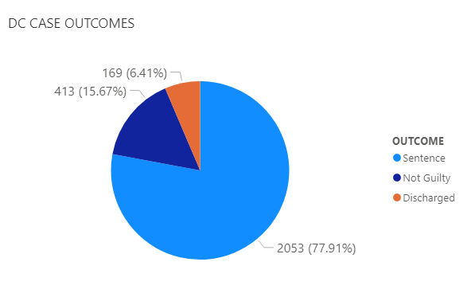
Figure 6: Verdicts breakdown for Apr 20 - Mar 21 in RC
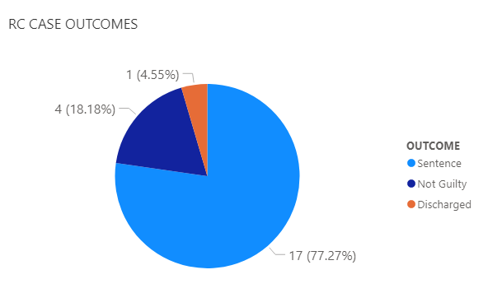

Figure 7: Verdicts breakdown for Apr 19- Mar 20 in DC
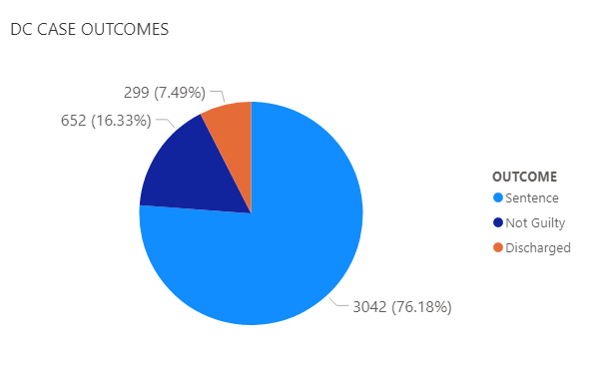

Figure 8: Verdicts breakdown for Apr 19- Mar 20 in RC

