36/1/4/1(201900228)
NATIONAL ASSEMBLY

FOR WRITTEN REPLY QUESTION 906
DATE OF PUBLICATION IN INTERNAL QUESTION PAPER: 13 SEPTEMBER 2019 (INTERNAL QUESTION PAPER NO 16-2019)

906. Mr A G Whitfield (DA) to ask the Minister of Police:

What number of (a) SA Police Service (SAPS) members were found guilty of criminal charges since 1 January 2009, (b) of what specified crimes were they found guilty of in each case and (c) of the specified members are still employed by SAPS‘?
NW2058E
REPLY:
The information that is required is not readily available and must be verified before it can be submitted. A request is made for an extension of six weeks, in order to provide the correct information.

Reply to question 906 recommended/

OM
KJ (SOEG)
Date: tfI19 -JO - NJ 1

GENERAL
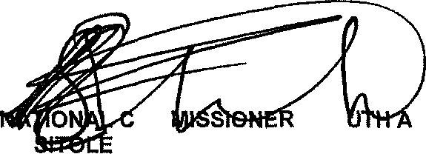
: SO FRICAN POLICE SERVICE

Reply to question 906 approved

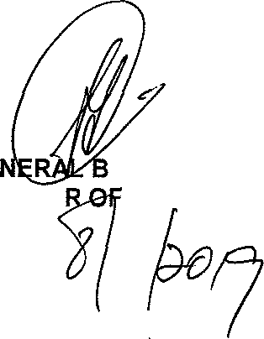
GE MINISTE
H CELE (MP) POLICE

