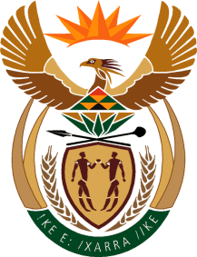

MINISTRY OF TOURISM
REPUBLIC OF SOUTH AFRICA

Private Bag X424, Pretoria, 0001, South Africa. Tel. (+27 12) 444 6780, Fax (+27 12) 444 7027
Private Bag X9154, Cape Town, 8000, South Africa. Tel. (+27 21) 469 5800, Fax: (+27 21) 465 3216

NATIONAL ASSEMBLY:

QUESTION FOR WRITTEN REPLY:
Question Number: 900
Date of Publication: 17 March 2023
NA IQP Number: 10
Date of reply:

Mr M S F de Freitas (DA) to ask the Minister of Tourism:
(a) On what date was the former Minister, Ms L N Sisulu, informed of the proposed sponsorship deal with Tottenham Hotspur Football Club for the first time and (b) what details was she furnished with regarding the specified sponsorship? NW1006E

REPLY:

- I was not appraised by the former Minister on when she was informed of the proposed sponsorship other than what was published in the media and a statement released by her former office on 1 February 2022, in which the former Minister confirmed that she was not consulted on the deal.

(b) Not Applicable.

