NATIONAL ASSEgflBLY
36/1/4/1(201900227)

FOR WRITTEN REPLY QUESTION 900
DATE OF PUBLICATION IN INTERNAL QUESTION PAPER: 13 SEPTEMBER 2019 (INTERNAL QUESTION PAPER NO 16-2019)

900. Mrs E N Ntlangwini (EFF) to ask the Minister of Police:

What plans has his department put in place to resolve the shortage of police vehicles at (a) Kensington and (b) Elsies River Police Stations in the Western Cape?
NW2052E
REPLY:
- A total of six new police vehicles have been ordered for the Kensington Police Station, in the 2019/2020 financial year.

- A total of four new police \/ehicles have been ordered for the Elsies River Police Station, in the 2019/2020 financial year.

Reply to question 900 recommended/

CO ISS
E (S

Date: 20ltl -09- 2 7
GENERAL UTH AFRICAN POLICE SERVICE

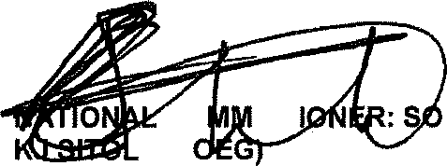
Reply to question 900 approVe oVed
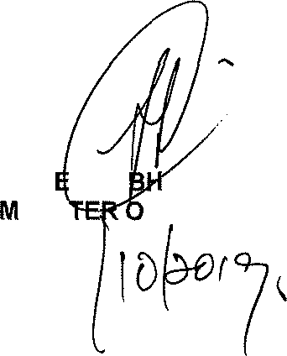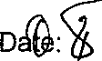

GEN RAL CELE (MP) INIS F POLICE

