PRIVATE BAG x 59, PRETORIA, £Q01, Tel (0J2) 444 3979, Fax (0J2) 444 3J45 PRIVATE BAG x 9111, CAPE TOWN, 8000 (021) 462 2310, Fax (021) 461 0859
Enquiries: Carmichael Ngalo e Carmichael.ngaloG'dmr.gov.za

Memorandum: Parliamentary Liaison Dffice

NATIONAL ASSEMBLY QUESTION FOR WRITTEN REPLY

QUESTION NUMBER: 80 ADVANCE NOTICE No: NW 995E

DATE OF PUBLICATION IN INTERNAL QUESTION PAPER: 20 June 2019 INTERNAL QUESTION PAPER NUMBER: 01
90. Ms M 0 Mokause (EFF) to ask the Minister of Mineral Resources and Energy:

What steps has his department taken to encourage the retraining of mine workers by mining companies in order to adjust to (a) automation and (b) new jobs?
NW1048E

Reply

The MPRDA provides for submission of a Social and Labour Plan (SLP) which is one of the requirements of the granting criteria. The Human Resource Development (HRD) is one of the elements of the SLP. Its key objective is to ensure that mining right holders provides for training of employees and community workers. The training provided is aimed at improving the skills base such that productivity is improved. Furthermore companies must provide portable skills which prepares employees to compete in the broader labour market. In order to

realise the HRD objective, mining right holders must invest a minimum 5% of leviable amount (excluding the statutory skills development levy) on essential skills development.

In the event that there might be threatening job losses, the mining right holders should identify and reskill workers with the objective of either adjusting to the new methods of working or competing in the labour market.
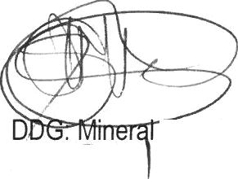
Date:

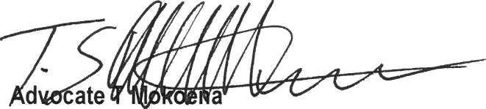
Recommendedl

Director General: Department of Mineral Resources

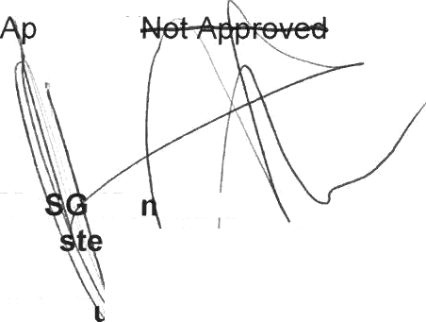
proved/

Mr Ma tasher
::

a:S::::

aIRD. ources

./2019

