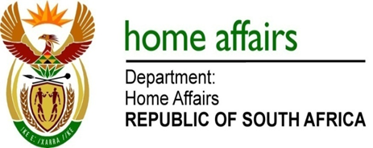

NATIONAL ASSEMBLY

QUESTION FOR WRITTEN REPLY

QUESTION NO. 90

DATE OF PUBLICATION: 7, THURSDAY, FEBRUARY 2019

INTERNAL QUESTION PAPER 1 OF 2019

90. Mr. M H Hoosen (DA)) to ask the Minister of Home Affairs:

What number of persons with citizenship of any of the other Southern African Development Community member states received South African citizenship between (a) 1 January 2017 and 31 December 2017 and (b) 1 January 2018 and 31 December 2018? NW95E

REPLY:

- Number of persons with citizenship from SADC between 01 January 2017 and 31 December 2017:

SADC COUNTRIES | TOTAL NUMBER OF NATURALISED CITIZENS PER COUNTRY
ANGOLA | 1
BOTSWANA | 0
DEMOCRATIC REPUBLIC OF CONGO | 46
ESWATINI | 16
LESOTHO | 53
MADAGASCAR | 0
MALAWI | 16
MAURITIUS | 0
MOZAMBIQUE | 141
NAMIBIA | 0
SEYCHELLES | 0
TANZANIA | 0
ZAMBIA | 5
ZIMBABWE | 142

- Number of persons with citizenship from SADC between 01 January 2018 and 31 December 2018:

SADC COUNTRIES | TOTAL NUMBER OF NATURALISED CITIZENS PER COUNTRY
ANGOLA | 5
BOTSWANA | 6
DEMOCRATIC REPUBLIC OF CONGO | 89
ESWATINI | 12
LESOTHO | 89
MADAGASCAR | 0
MALAWI | 18
MAURITIUS | 5
MOZAMBIQUE | 160
NAMIBIA | 1
SEYCHELLES | 0
TANZANIA | 3
ZAMBIA | 14
ZIMBABWE | 141

