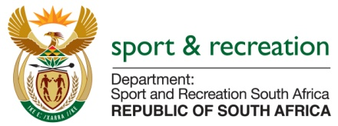

PARLIMENTARY QUESTION FOR THE MINISTER

Question Number 898 from Mr P G Moteka (EFF) to ask the Minister of Sport and Recreation:

Question Number 898 from Mr P G Moteka (EFF) to ask the Minister of Sport and Recreation:

(1) has he earned any additional income from businesses, in particular businesses doing work for the Government, since his appointment as Minister; if so, (a) when, (b) how much did he earn, (c) from which businesses and (d) for what work;

(2) whether his (a) spouse, (b) children and (c) close family earned income from businesses, in particular businesses doing work for the Government, through his appointment as Minister; if so, in respect of each case, (i) when, (ii) how much did each earn, (iii) from which businesses and (iv) for what work? NW1024E

REPLY

1) No

a) Not applicable
b) Not applicable
c) Not applicable
d) Not applicable

2) No

(i) Not applicable
(ii) Not applicable
(iii) Not applicable
(iv) Not applicable

