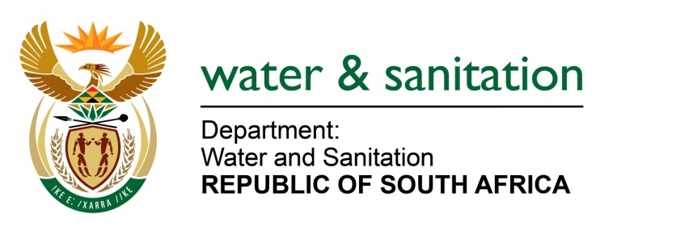

NATIONAL ASSEMBLY

FOR WRITTEN REPLY

QUESTION NO 897

DATE OF PUBLICATION IN INTERNAL QUESTION PAPER: 11 APRIL 2016
(INTERNAL QUESTION PAPER NO. 10)

897. Ms M S Khawula (EFF) to ask the Minister of Water and Sanitation:

(1) Has she earned any additional income from businesses, in particular businesses doing work for the Government, since her appointment as Minister; if so, (a) when, (b) how much did she earn, (c) from which businesses and (d) for what work;

(2) whether her (a) spouse, (b) children and (c) close family earned income from businesses, in particular businesses doing work for the Government, through her appointment as Minister; if so, in respect of each case, (i) when, (ii) how much did each earn, (iii) from which businesses and (iv) for what work? NW1023E
---00O00---
REPLY:
(1) No, I have not earned any additional income from any businesses.
(2) No, no members of my family have earned any additional income from any businesses doing business with government.
---00O00---

