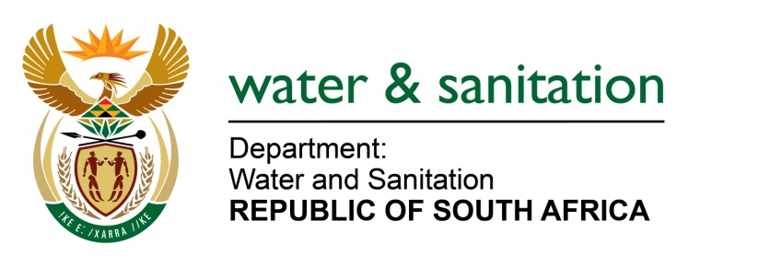

MINISTER OF WATER AND SANITATION

FOR WRITTEN REPLY

QUESTION NO 896

DATE OF PUBLICATION IN INTERNAL QUESTION PAPER: 11 MARCH 2022
(INTERNAL QUESTION PAPER NO. 9)

896. Mr E J Marais (DA) to ask the Minister of Water and Sanitation:

What (a) is the total number of incidents of (i) sexual harassment and (ii) sexual assault that were reported in his department (aa) in each of the past three financial years and (bb) since 1 April 2021, (b) number of cases (i) were opened and concluded, (ii) were withdrawn and (iii) remain open or pending based on the incidents and (c) sanctions were meted out against each person who was found guilty?
NW1077E
---00O00---

MINISTER OF WATER OF WATER AND SANITATION

To date, there are no sexual harassment cases that are pending. For the past three financial years, only one case was reported, which has since been withdrawn.

---00O00--

