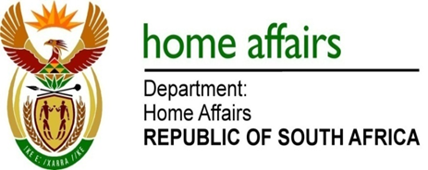

NATIONAL ASSEMBLY

QUESTION FOR WRITTEN REPLY

QUESTION NO. 896

DATE OF PUBLICATION: FRIDAY, 23 MARCH 2018

INTERNAL QUESTION PAPER 9 OF 2018

896. Mr M Waters (DA) to ask the Minister of Home Affairs:

(a) Who took the decision to appeal the report by the Public Protector entitled Inappropriate Moves, (b) can he provide Mr M Waters with the minutes which reflect the decision that was taken and (c) what was the total cost of the appeal to the Independent Electoral Commission? NW975E

REPLY:

The question was referred to the Electoral Commission which responded as follows:

- The Electoral Commission did not file an appeal against the Public Protector Report.
- There are therefore no minutes reflecting that decision.
- There were no costs incurred as there was no appeal against the Public Protector Report.

