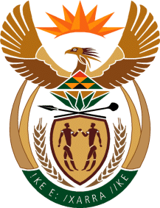

MINISTER IN THE PRESIDENCY: REPUBLIC OF SOUTH AFRICA
Private Bag X1000, Pretoria, 0001, Union Buildings, Government Avenue, PRETORIA
Tel: (012) 300 5200, Website: www.thepresidency.gov.za

NATIONAL ASSEMBLY
WRITTEN QUESTION FOR WRITTEN REPLY
QUESTION NUMBER: 894
DATE OF PUBLICATIONS: 11 March 2022

894. Mr T R Majola (DA) to ask the Minister in The Presidency:

What (a) is the total number of incidents of (i) sexual harassment and (ii) sexual assault that were reported in his Office (aa) in each of the past three financial years and (bb) since 1 April 2021, (b) number of cases (i) were opened and concluded, (ii) were withdrawn and (iii) remain open or pending based on the incidents and (c) sanctions were meted out against each person who was found guilty? NW1075E
REPLY:

There were no incidents of sexual harassment and/or sexual assault cases reported in the past three financial years, and the status quo remains since 1 April 2021 to date in my office.

Thank You.

