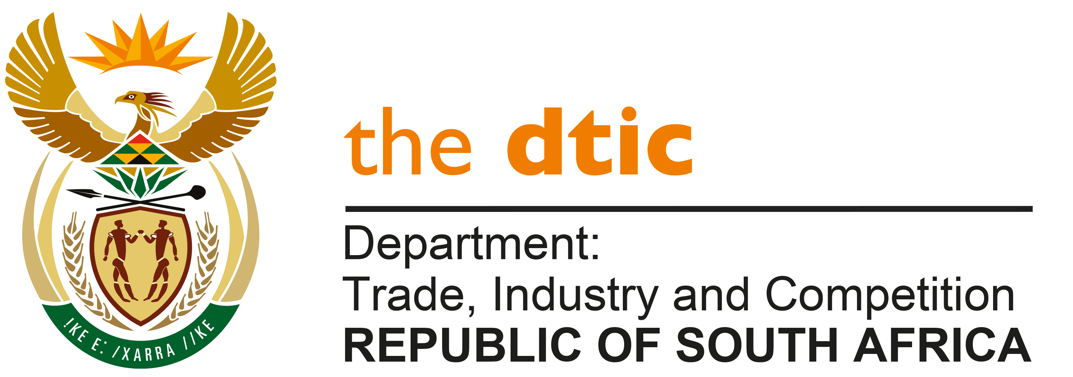

THE NATIONAL ASSEMBLY

QUESTION FOR WRITTEN REPLY

QUESTION NO. 892

DATE PUBLISHED: 11 MARCH 2022

Mr M S Mabika (DA) to ask the Minister of Trade, Industry and Competition:

What (a) is the total number of incidents of (i) sexual harassment and (ii) sexual assault that were reported in his department (aa) in each of the past three financial years and (bb) since 1 April 2021, (b) number of cases (i) were opened and concluded, (ii) were withdrawn and (iii) remain open or pending based on the incidents and (c) sanctions were meted out against each person who was found guilty? [NW1073E]

REPLY:

- There were no incidents of sexual harassment or sexual assault reported during the past three (3) financial years and since 1 April 2021.

- and (c) There were no cases of sexual harassment opened/withdrawn and thus no sanctions had to be issued.

-END-

