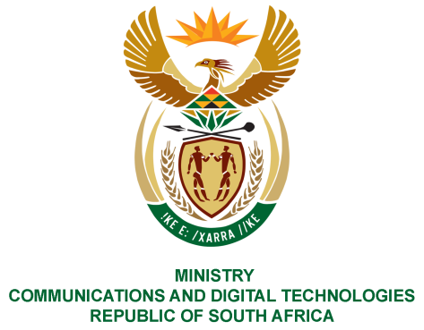
PARLIAMENT OF THE REPUBLIC OF SOUTH AFRICA
NATIONAL ASSEMBLY
WRITTEN REPLY

QUESTION NO: 888
DATE OF PUBLICATION: 17 March 2023
QUESTION PAPER NO:
Ms D Kohler (DA) to ask the Minister of Communications and Digital Technologies:
(1) Whether his department had developed an integrated Government programme of action (POA) on addressing violence against women, children and persons with disabilities; if not, why not; if so, by what date will the specified POA be implemented;
(2) whether his department has developed a framework for women, youth and persons with disabilities to participate in the Information and Communication Technology sector; if not, why not; if so, by what date will the specified framework be implemented?
NW994E
REPLY:

- The Department has developed a response to the NSP on GBV and it is being implemented in partnership with the State-Owned Entities and stakeholders.

- The department has developed a framework for women, youth and persons with disabilities to participate in the Information and Communication Technology sector and it will be implemented by March 2024

Thank You.

