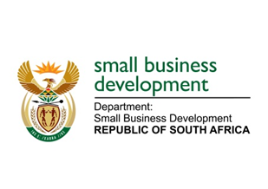
NATIONAL ASSEMBLY
QUESTION FOR WRITTEN REPLY
DUE IN PARLIAMENT: FRIDAY, 25 MARCH 2022

888. Dr A Lotriet (DA) to ask the Minister of Small Business Development:

What (a) is the total number of incidents of (i) sexual harassment and (ii) sexual assault that were reported in her department (aa) in each of the past three financial years and (bb) since 1 April 2021, (b) number of cases (i) were opened and concluded, (ii) were withdrawn and (iii) remain open or pending based on the incidents and (c) sanctions were meted out against each person who was found guilty? NW1069E

REPLY: I have been advised by the department as follows:

No cases of sexual harassment and sexual assault were reported during the afore-mentioned period.

STELLA NDABENI-ABRAHAMS
MINISTER: SMALL BUSINESS DEVELOPMENT

