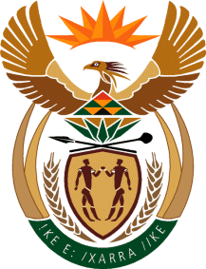

MINISTRY OF TOURISM
REPUBLIC OF SOUTH AFRICA

Private Bag X424, Pretoria, 0001, South Africa. Tel. (+27 12) 444 6780, Fax (+27 12) 444 7027
Private Bag X9154, Cape Town, 8000, South Africa. Tel. (+27 21) 469 5800, Fax: (+27 21) 465 3216

NATIONAL ASSEMBLY:

QUESTION FOR WRITTEN REPLY:
Question Number: 888
Date of Publication: 12 March 2021
NA IQP Number: 8
Date of reply: 23 April 2021

Mr K P Sithole (IFP) to ask the Minister of Tourism:
How will her department be assisting the tourism sector in the Republic in order to reinvigorate the (a) international market and (b) domestic market in respect of South Africa being once again an ideal tourist destination post the vaccine rollout period? NW1055E
REPLY:

- International market.
South African Tourism has kept all its international trade partners and stakeholders regularly updated on key matters of relevance to travel to South Africa. The continuous flow of information helps to sensitize international markets of the situation in South Africa and highlights the high standard of safety protocols adopted and implemented by the tourism industry. This will boost the confidence in the destination and inspire travel choices in favour of South Africa. On the business events front, SA Tourism together with the industry players participated at various events, meetings and conferences aimed at invigorating the industry through virtual platforms. On the economic diplomacy front, the Minister is leading engagements with missions of market countries and also reaching out to our key trade partners to provide insights on facts related to tourism and the pandemic in South Africa. All these are part of the regional and international market rejuvenation campaign.

- Domestic market.
The domestic tourism campaign led by the Minister and supported by the Deputy Minister has been rolled out across all provinces in the country, showcasing some of the best but less known attractions. The campaign is supported through both mainstream and digital media platforms. While official account of the sector’s domestic recovery performance is yet to be compiled, indications from the sector are that these efforts are bearing fruits and that domestic tourism is on its way to recovery dependant on the pandemic trends.

