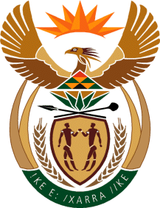

MINISTRY: COMMUNICATIONS
REPUBLIC OF SOUTH AFRICA
Private Bag X 745, Pretoria, 0001, Tel: +27 12 473 0164 Fax: +27 12 473 0585
Tshedimosetso House,1035 Francis Baard Street, Tshedimosetso House, Pretoria, 1000

NATIONAL ASSEMBLY
QUESTION FOR WRITTEN REPLY
QUESTION NUMBER: 886
DATE OF PUBLICATION: APRIL 2016

886. Mr M Q Ndlozi (EFF) to ask the Minister of Communications:

(1) Has she earned any additional income from businesses, in particular businesses doing work for the Government, since her appointment as Minister; if so, (a) when, (b) how much did she earn, (c) from which businesses and (d) for what work;

(2) whether her (a) spouse, (b) children and (c) close family earned income from businesses, in particular businesses doing work for the Government, through her appointment as Minister; if so, in respect of each case, (i) when, (ii) how much did each earn, (iii) from which businesses and (iv) for what work? NW1012E

REPLY: MINISTER OF COMMUNICATIONS

- The Minister declares all her financial interests annually which are public knowledge.
- (a) No (b) No (c) No

MS B BALOYI
CHIEF OF STAFF
MINISTRY OF COMMUNICATIONS
DATE:

MR NN MUNZHELELE
DIRECTOR GENERAL [ACTING]
DEPARTMENT OF COMMUNICATIONS
DATE:

MS AF MUTHAMBI (MP)
MINISTER OF COMMUNICATIONS
DATE

