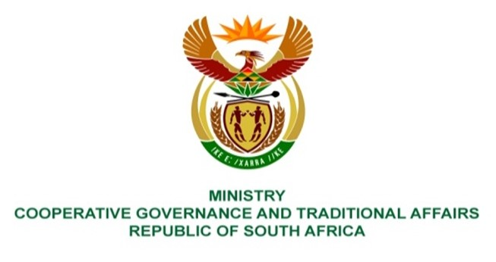

NATIONAL ASSEMBLY
QUESTIONS FOR WRITTEN REPLY

QUESTION NUMBER 2021/882
DATE OF PUBLICATION: 12 MARCH 2021

Mr T C R Walters (DA) to ask the Minister of Cooperative Governance and Traditional Affairs:
QUESTION:

(1) Whether any drought relief funding has been provided to the (a) Ndlambe Local Municipality, (b) Makana Local Municipality and (c) Ngqushwa Local Municipality over the past three financial years; if not, why not; if so, (i) what total amounts were provided in each case and (ii) what was the intended usage of such funds;

(2) whether the funds were utilised for the purposes intended; if not, in each case, why not; if so; what are the relevant details in each case;

(3) whether the projects for which the funds were intended were completed successfully; if not, why not; if so, what are the relevant details;

(4) what assistance is her department providing to the municipalities to assist with their water shortage problems? NW1049E

REPLY:

- Yes, drought relief funds were provided by the Department of Cooperative
Governance (DCOG) during the national financial year 2017/2018 to (a) Ndlambe Local Municipality, (b) Makana Local Municipality and (c) no funds were provided to Ngqushwa Local Municipality.

(i) The total amounts provided to the municipalities were as follows:
- Ndlambe Local Municipality – R950 000
- Makana Local Municipality – R810 000

(ii) The intended purpose for funds allocated to Ndlambe and Makana Local Municipalities was for drought intervention projects, particularly the recommissioning of boreholes and related water infrastructure that were not functional within the municipalities.

- the reports from both municipalities indicated that the funds
were used for the intended purposes for drought interventions within the municipality;

- the projects for which the funds were intended were completed successfully
as per the reports submitted by the municipalities;

- the DCOG continues to support all municipalities within the country, including
the mentioned municipalities through normal existing departmental programme, particularly the Municipal Infrastructure Grant (MIG) regarding annual funding allocations for water and sanitation infrastructure for development and service delivery enhancement within the municipalities.

