NATIONAL ASSEMBLY

FOR WRITTEN REPLY

QUESTION NO. 880

DATE OF PUBLICATION IN INTERNAL QUESTION PAPER: 17 MARCH 2023
(INTERNAL QUESTION PAPER NO. 10)
Mr P A van Staden (FF Plus) to ask the Minister of Health:
(1) Whether, with reference to the current Eskom crisis and electricity blackouts at state and provincial hospitals, he will indicate (a) what the total amounts are that were spent on diesel for generators by each hospital in each province during the period 1 April 2022 up to 28 February 2023 and (b) if the generators at all hospitals across the Republic are in a workable condition; if not, why not, in each case; if so, what are the relevant details in each case;
(2) whether he will make a statement on the matter? NW986E
REPLY:
- (a) See below the breakdown on the expenditure for the diesel consumption by the generators in each province:

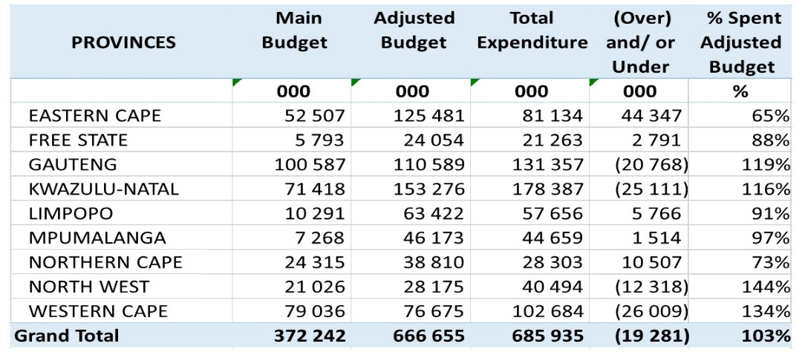
Annexure A is attached and it covers a breakdown expenditure for diesel usage by generators for each hospital in the Republic.
- Yes, the generators are in a workable condition.

- I will not be making a statement on this matter.

END.

