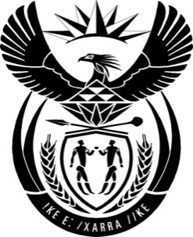

THE PRESIDENCY: REPUBLIC OF SOUTH AFRICA
Private Bag X1000, Pretoria, 0001
NATIONAL ASSEMBLY
QUESTIONS FOR WRITTEN REPLY

QUESTION NO: 876

Date Published: 11 April 2016

Mr W M Madisha (Cope) to ask the President of the Republic:
(1)Whether he was continuously ensuring that all Cabinet members and Deputy Ministers were complying fully with section 96(1) and (2) of the Constitution of the Republic of South Africa, 1996; if not, why not; if so, what steps has he taken to ensure that the Constitution of the Republic of South Africa, 1996, was being fully complied with by every member of the Executive and every Deputy Minister;
(2)Whether he will make a statement on the strict adherence to the Code of Ethics in terms of the Executive Members’ Ethics Act, Act 82 of 1998, in the Government that he leads and the extent to which this is being done by The Presidency?
NW999E
Reply:
Constitutional democracy means supremacy of the rule of law as prescribed by the Constitution. The Constitution places certain responsibilities on the President and the Executive collectively. The steps required to be taken by the Executive are clearly spelt out in the Constitution and applicable legislation.
Members of the Executive do comply with their legal obligations as set out in the Constitution. They appear in Parliament to discharge their obligations as and when required, such as through attending parliamentary sittings, answering parliamentary questions, participate in debates, attending meetings of portfolio committees and various other activities.

