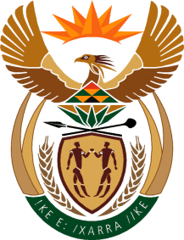

MINISTRY OF TOURISM
REPUBLIC OF SOUTH AFRICA

Private Bag X424, Pretoria, 0001, South Africa. Tel. (+27 12) 444 6780, Fax (+27 12) 444 7027
Private Bag X9154, Cape Town, 8000, South Africa. Tel. (+27 21) 469 5800, Fax: (+27 21) 465 3216

NATIONAL ASSEMBLY:

QUESTION FOR WRITTEN REPLY:
Question Number: 873
Date of Publication: 12 March 2021
NA IQP Number: 8
Date of reply: 30 April 2021

Ms H S Winkler (DA) to ask the Minister of Tourism:
What (a) total number of project targets were missed in the first, second and third quarter of the 2020-21 financial year due to failure to appoint third party service providers, (b) are the details of the specified projects and (c) is the time frame for appointment of the third party service providers to ensure that delayed targets are met? NW1038E

REPLY:
- The department presented the reports for Quarters 1, 2 and 3 of the 2020/21 financial year on the following dates respectively, 06 October 2020 and 02 March 2021. The reports contained details on areas of achievements, areas where quarterly targets were missed, reasons for non-achievement and the corrective measures.

- The Honorable member is referred to the reports as previously submitted to the Portfolio Committee on Tourism.

- The final information on the achievement of targets has not been verified/confirmed through audit processes as yet. The member will be furnished with the final details once the Annual Performance Report is tabled after the audit processes.

