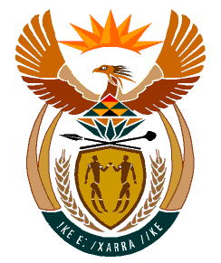

MINISTRY:
HUMAN SETTLEMENTS, WATER AND SANITATION
REPUBLIC OF SOUTH AFRICA

NATIONAL ASSEMBLY

QUESTION FOR WRITTEN REPLY

QUESTION NO.: 873

DATE OF PUBLICATION: 15 MAY 2020

Mr L J Basson (DA) to ask the Minister of Human Settlements, Water and Sanitation:
(1) Whether her department will offer any form of Covid-19 financial or other relief to small businesses; if not, why not; if so, what are the relevant details;
(2) whether the Covid-19 financial or other relief will only be allocated to qualifying small businesses according to the Broad-Based Black Economic Empowerment Act, Act 53 of 2003, as amended; if not, what is the position in this regard; if so, (a) on what statutory grounds and/or provisions does she or her department rely to allocate Covid-19 financial or other relief only to small businesses according to the specified Act and (b) what form of Covid-19 financial or other relief, if any, will be made available to other small businesses? NW1080E

REPLY:
(1) The matter raised by the Honourable Member does not fall within mandate of the Department of Water and Sanitation or the Department of Human Settlements.
(2) Not applicable.

