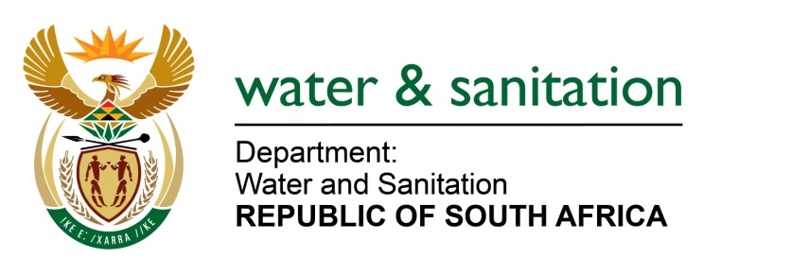

NATIONAL ASSEMBLY

FOR WRITTEN REPLY

QUESTION NO 872

DATE OF PUBLICATION IN INTERNAL QUESTION PAPER: 17 MARCH 2023
(INTERNAL QUESTION PAPER NO. 10)

872. Mrs M R Mohlala (EFF) to ask the Minister of Water and Sanitation:
What (a) reasons lie behind the delayed completion of the James Kleynhans Water Treatment Works upgrade, (b) steps have been taken to avoid such delays in the future, (c) are the long-term implications for the Republic’s water infrastructure if such delays continue and (d) total amount in funding will be required to complete the specified upgrade by 31 December 2023? NW978E

---00O00---
MINISTER OF WATER AND SANITATION

- The delays in the completion of Phase 2 upgrade of James Kleynhans Water Treatment Works (WTW’s) are due to the following:
- The Covid 19 hard lockdown resulted in work stoppages and revised health and safety measures that needed to be implemented
- The lockdowns also brought about increases in costs of various materials and equipment for the project
- The contractor initially appointed experienced financial difficulties which slowed progress of activities and ultimately liquidation of the company which resulted in the contract being terminated.

- Procurement processes to appoint a new contractor were also delayed as the advertisement of the tender had to be repeated due to unresponsive bids during the first round.

The contractor was eventually appointed and the has been on site since January 2023.

- The Department is closely monitoring the turnaround plan of the Amatola Water Board and the municipality convenes monthly progress meetings.

- Any further delays in completing water infrastructure projects may result in water shortages in cities and towns as the ageing Water Treatment Works may eventually not be able to meet the increased demands for water.

- An estimated amount of R88,4 million is required to complete Phase 2 of the project by December 2023.

---00O00---

