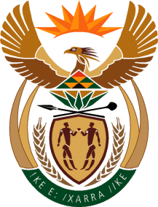

MINISTRY OF TOURISM
REPUBLIC OF SOUTH AFRICA

Private Bag X424, Pretoria, 0001, South Africa. Tel. (+27 12) 444 6780, Fax (+27 12) 444 7027
Private Bag X9154, Cape Town, 8000, South Africa. Tel. (+27 21) 469 5800, Fax: (+27 21) 465 3216

NATIONAL ASSEMBLY:

QUESTION FOR WRITTEN REPLY:
Question Number: 872
Date of Publication: 12 March 2021
NA IQP Number: 8
Date of reply: 31 March 2021

Ms H S Winkler (DA) to ask the Minister of Tourism:
(a) On what date will the Rail Tourism Survey Report be completed and (b) what (i) is the objective of the Rail Tourism Survey and (ii) are the details of the steps towards the completion of the Rail Tourism Survey? NW1037E

REPLY:

- The Rail Tourism Survey Report will be completed on 31 March 2021

- (i) Objective of the Rail Tourism Survey is:
To understand the rail tourism environment through exploring and assessing various aspects (nature of the concept, market demand and supply issues, planning and operational modalities, funding, monitoring and evaluation mechanisms with key stakeholders), with the objective to inform policy, viability processes, support rail tourism analysis functions, route utilisation strategies, regional planning assessments, rail tourism economic models, rail scheme assessments and station catchment analysis.

(ii) The details of the steps towards the completion of the Rail Tourism Survey.
The approach covers the following steps:
- Project Orientation that lead to an Inception Report
- Literature Review and Survey Framework that lead to a Survey framework
- Data collection that lead to a data collection report
- Survey Analysis that lead to a Data Analysis Report
- Reporting and Project Closure that lead to the final Survey Report and close- out Report

