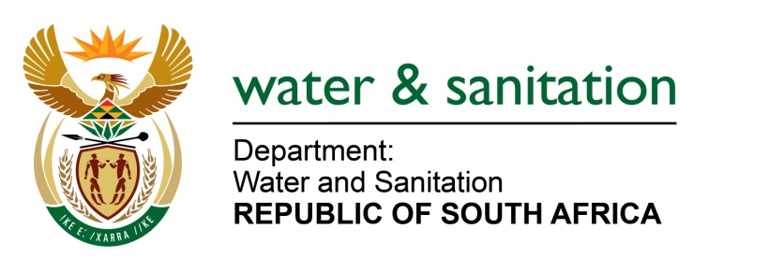

NATIONAL ASSEMBLY

FOR WRITTEN REPLY

QUESTION NO 871

DATE OF PUBLICATION IN INTERNAL QUESTION PAPER: 17 MARCH 2023
(INTERNAL QUESTION PAPER NO. 10)

871. Mrs M R Mohlala (EFF) to ask the Minister of Water and Sanitation:
What immediate intervening steps has his department taken to ensure the safety and security of workers at water projects, who are currently being held to ransom by construction mafias?
NW977E
---00O00---
MINISTER OF WATER AND SANITATION
The Department of Water and Sanitation has encountered challenges with business forums that demand 30% of funds allocated for Regional Bulk infrastructure Grant (RBIG) and Water Services Infrastructure Grant (WSIG) projects be allocated to them.
The DWS through project steering committees, engages business forums to find amicable solutions to address contract management matters. This is spearheaded by different implementing agents and supported by the Ministry, and senior officials of the Department. Where necessary, the Department will request police protection for its staff, and/or provide private security protection.
---00O00---

