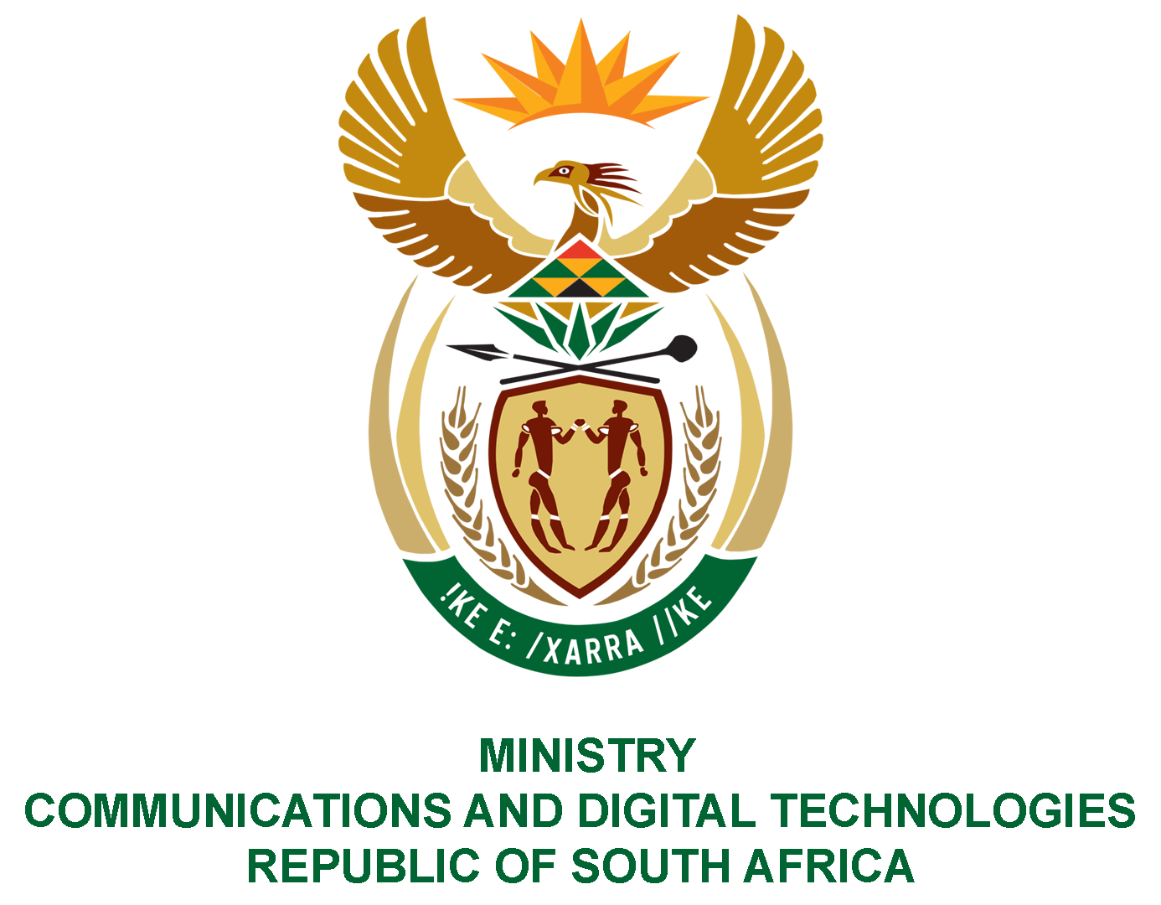

PARLIAMENT OF THE REPUBLIC OF SOUTH AFRICA

NATIONAL ASSEMBLY

WRITTEN REPLY

QUESTION: 871

DATE OF PUBLICATION: 11 MARCH 2022
QUESTION PAPER NO: 09
Ms N K Sharif (DA) to ask the Minister of Communications and Digital Technologies:
What (a) is the total number of incidents of (i) sexual harassment and (ii) sexual assault that were reported in her department (aa) in each of the past three financial years and (bb) since 1 April 2021, (b) number of cases (i) were opened and concluded, (ii) were withdrawn and (iii) remain open or pending based on the incidents and (c) sanctions were meted out against each person who was found guilty?
NW1052E

REPLY

I have been advised by the Department as follows:

No incidents of sexual harassment and sexual assault were reported in the Department in the past three years and since 1 April 2021.

Authorised for submission by

MS. NONKQUBELA JORDAN-DYANI
DIRECTOR-GENERAL (ACTING)
DATE:

Recommended/not recommended

__________________________
HON. PHILLY MAPULANE, MP
DEPUTY MINISTER OF COMMUNICATIONS AND DIGITAL TECHNOLOGIES
DATE:

Approved/ not approved

________________________________
HON. KHUMBUDZO NTSHAVHENI, MP
MINISTER OF COMMUNICATIONS AND DIGITAL TECHNOLOGIES
DATE:

