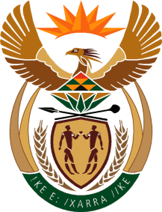

MINISTRY OF TOURISM
REPUBLIC OF SOUTH AFRICA

Private Bag X424, Pretoria, 0001, South Africa. Tel. (+27 12) 444 6780, Fax (+27 12) 444 7027
Private Bag X9154, Cape Town, 8000, South Africa. Tel. (+27 21) 469 5800, Fax: (+27 21) 465 3216

NATIONAL ASSEMBLY:

QUESTION FOR WRITTEN REPLY:
Question Number: 87
Date of Publication: 13 February 2020
NA IQP Number: 1
Date of reply: 26 February 2020

Mr M S F De Freitas (DA) to ask the Minister of Tourism:

(a) What (i) strategies and (ii) programmes are in place and are being planned to boost tourism by (aa) her department (bb) her department in conjunction with other departments and (cc) state-owned entities, (b) what are the details of the specified departments and state-owned entities and (c) how are they involved in these strategies and programmes? NW96E

REPLY:
The Department and SA Tourism’s programmes and strategies to boost tourism are contained in the tabled Strategic Plans and Annual Performance Plan.

Furthermore, future plans will be tabled in Parliament on 11 March 2020.

