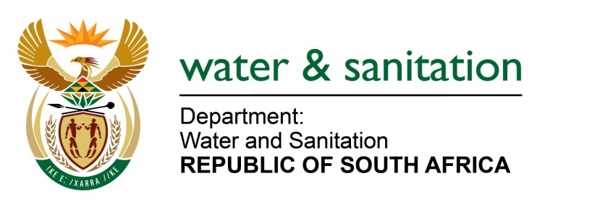

MINISTER OF WATER AND SANITATION

FOR WRITTEN REPLY

QUESTION NO 868

DATE OF PUBLICATION IN INTERNAL QUESTION PAPER: 11 MARCH 2022
(INTERNAL QUESTION PAPER NO. 9)

868. Mr N E Hinana (DA) to ask the Minister of Water and Sanitation:
What total amount in Rand has been spent on (a) catering, (b) entertainment and (c) accommodation for (i) him, (ii) the Deputy Ministers and (iii) officials of his department since 29 May 2019?
---00O00---
MINISTER OF WATER AND SANITATION
2019/20 financial year
 | (a) catering | (b) entertainment | (c) accommodation
 | R'000 | R'000 | R'000
(i) Minister | 2 | 3 | 1 464
(ii) Deputy Ministers | - | - | 2 035
(iii) Officials | 1 443 | 144 | 23 635
Total | 1 445 | 147 | 27 134

2020/21 financial year
 | (a) catering | (b) entertainment | (c) accommodation
 | R'000 | R'000 | R'000
(i) Minister | - | 2 | 654
(ii) Deputy Ministers | - | - | 345
(iii) Officials | 317 | 22 | 17 175
Total | 317 | 24 | 18 174

2021/22 financial year
 | (a) catering | (b) entertainment | (c) accommodation
 | R'000 | R'000 | R'000
(i) Minister | 106 | 3 | 1 897
(ii) Deputy Ministers | 3 | 3 | 1 219
(iii) Officials | 860 | 58 | 34 818
Total | 969 | 64 | 37 934

Total amount spent
 | (a) catering | (b) entertainment | (c) accommodation
 | R'000 | R'000 | R'000
(i) Minister | 108 | 8 | 4 015
(ii) Deputy Ministers | 3 | 3 | 3 599
(iii) Officials | 2 620 | 224 | 75 628
Total | 2 731 | 235 | 83 242

---00O00---

